SUPPLIMENTARY MATERIAL
Table S1: The P. putida strains genomes retrieved from NCBI and IMG databases in March, 2016.
Organism/Name | Strain | BioProject | Assembly | Size (Mb) | Replicons
P. putida NBRC 14164 | NBRC 14164 | PRJDB191 | GCA_000412675.1 | 6.1567 | NC021505.1/AP013070.1
P. putida F1 | F1 | PRJNA13909 | GCA_000016865.1 | 5.95996 | NC009512.1/CP000712.1
P. putida GB-1 | GB-1 | PRJNA17629 | GCA_000019125.1 | 6.07843 | chromosome:NC_010322.1/CP000926.1
P. putida W619 | W619 | PRJNA17053 | GCA_000019445.1 | 5.77433 | chromosome:NC_010501.1/CP000949.1
P. putida BIRD-1 | BIRD-1 | PRJNA54033 | GCA_000183645.1 | 5.73154 | chromosome:NC_017530.1/CP002290.1
P. putida S16 | S16 | PRJNA67881 | GCA_000219705.1 | 5.98479 | chromosome:NC_015733.1/CP002870.1
P. putida ND6 | ND6 | PRJNA162897 | GCA_000264665.1 | 6.20245 | chromosome:NC_017986.1/CP003588.1  plasmid pND6-2:NC_018746.1/CP003589.1
P. putida HB3267 | PC9 | PRJNA171349 | GCA_000325725.1 | 5.95611 | chromosome:NC_019905.1/CP003738.1  plasmid pPC9:NC_019906.1/CP003739.1
P. putida H8234 | H8234 | PRJNA202087 | GCA_000410575.1 | 6.87083 | chromosome:NC_021491.1/CP005976.1
P. putida S12 | S12 | PRJNA222630 | GCA_000495455.2 | 6.38243 | chromosome:NZ_CP009974.1/CP009974.1  plasmid pTTS12:NZ_CP009975.1/CP009975.1
P. putida S13.1.2 | S13.1.2 | PRJNA214610 | GCA_000498395.3 | 6.62185 | chromosome:NZ_CP010979.1/CP010979.1
P. putida | DLL-E4 | PRJNA244741 | GCA_000691565.1 | 6.48406 | chromosome:NZ_CP007620.1/CP007620.1
P. putida | 1A00316 | PRJNA307468 | GCA_001515585.2 | 5.71582 | chromosome:NZ_CP014343.1/CP014343.1
P. putida | PC2 | PRJNA286152 | GCA_001636055.1 | 5.80862 | chromosome:NZ_CP011789.1/CP011789.1
P. putida | PD1 | PRJNA247591 | GCA_000799625.1 | 5.99714 | -
P. putida | PA14H7 | PRJNA236584 | GCA_000800615.1 | 5.87875 | -
P. putida B6-2 | B6-2 | PRJNA72885 | GCA_000226035.2 | 6.2396 | -
P. putida str. Idaho | Idaho | PRJNA72621 | GCA_000226475.2 | 6.36307 | -
P. putida SJTE-1 | SJTE-1 | PRJNA167271 | GCA_000271965.1 | 5.5515 | -
P. putida B001 | B001 | PRJEA68177 | GCA_000285395.1 | 5.74094 | -
P. putida S12 | S12 | PRJNA171340 | GCA_000287915.1 | 6.28466 | -
P. putida LS46 | LS46 | PRJNA167222 | GCA_000294445.2 | 5.87476 | -
P. putida CSV86 | CSV86 | PRJNA65243 | GCA_000319305.1 | 6.46978 | -
P. putida TRO1 | TRO1 | PRJNA174070 | GCA_000367825.1 | 6.31521 | -
P. putida MTCC 5279 | MTCC5279 | PRJNA176888 | GCA_000411615.1 | 5.21579 | -
P. putida SJ3 | SJ3 | PRJNA215701 | GCA_000478865.1 | 6.33139 | -
P. putida S610 | S610 | PRJNA218557 | GCA_000497385.1 | 4.59635 | -
P. putida OUS82 | OUS82 | PRJNA223432 | GCA_000507325.1 | 6.63331 | -
P. putida W15Oct28 | W15Oct28 | PRJNA235256 | GCA_000708715.2 | 6.32051 | -
P. putida T2-2 | T2-2 | PRJNA235245 | GCA_000710785.1 | 5.52423 | -
P. putida | MC4-5222 | PRJNA253005 | GCA_000729805.1 | 6.8581 | -
P. putida | YKD221 | PRJDB2892 | GCA_000787655.1 | 5.87071 | -
P. putida | SQ1 | PRJNA266268 | GCA_000802565.1 | 5.32094 | -
P. putida | KF703 | PRJDB3352 | GCA_000875995.1 | 6.4349 | -
P. putida | UASWS0946 | PRJNA268580 | GCA_000878325.1 | 6.0013 | -
P. putida KG-4 | KG-4 | PRJNA223514 | GCA_000987155.1 | 5.58691 | -
P. putida | CBB5 | PRJNA267498 | GCA_001006135.1 | 6.81706 | -
P. putida | SF1 | PRJNA284837 | GCA_001027965.1 | 5.80588 | -
P. putida | 791_PPUT | PRJNA267549 | GCA_001066335.1 | 6.24298 | -
P. putida | PCL1760 | PRJNA289510 | GCA_001282125.1 | 5.77208 | -
P. putida | IOFA1 | PRJNA289292 | GCA_001293025.1 | 5.7088 | -
P. putida | HB13667 | PRJNA287247 | GCA_001306495.1 | 6.3255 | -
P. putida | HB4184 | PRJNA287249 | GCA_001306515.1 | 5.93051 | -
P. putida JCM 18452 | JCM 18452 | PRJDB837 | GCA_001312165.1 | 6.28482 | -
P. putida | FDAARGOS_121 | PRJNA231221 | GCA_001471435.1 | 6.95803 | -
P. putida | JQ581 | PRJNA316053 | GCA_001630725.1 | 6.56391 | -
P. putida LF54 | LF54 | PRJNA190835 | GCA_000390005.2 | 5.62502 | -
P. putida | ATH-43 | PRJNA278654 | GCA_001005285.1 | 5.83022 | -
P. putida | H | PRJNA287355 | GCA_001077495.1 | 6.0599 | -
P. putida | JLR11 | PRJNA284264 | GCA_001183585.1 | 6.10037 | -
P. putida | ABAC8 | PRJNA296832 | GCA_001467305.1 | 5.5438 | -
P. putida | BW11M1 | PRJNA311277 | GCA_001562525.1 | 5.45688 | -
P. putida DOT-T1E | DOT-T1E | PRJNA167844 | GCA_000281215.1 | 6.2607 | chromosome:CP003734.1
P. putida S11 | S11 | PRJNA171810 | GCA_000292775.1 | 5.97075 | -
P. putida JCM 9802 | JCM 9802 | PRJDB836 | GCA_001312145.1 | 6.03523 | -
P. putida JCM 18798 | JCM 18798 | PRJDB838 | GCA_001312185.1 | 6.57759 | -
P. putida | ABAC63 | PRJNA295871 | GCA_001467195.1 | 5.13991 | -
P. putida MR3 | MR3 | PRJNA195540 | GCA_000390445.1 partial | 2.99472 | -
*

Table S2: The biosynthetic gene clusters for each P. putida strain and predicted chemical structures.
 | Strains | Clusters with Ref ID | Most similar known cluster with MIBiG BGC-ID | Predicted Structure
1 | KT2440 | - Cluster1 Bacteriocin  - NC_002947.3 | N.A | Putative chemical scaffold for cluster 3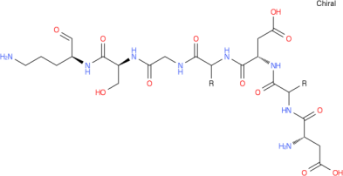  Putative chemical scaffold for cluster 4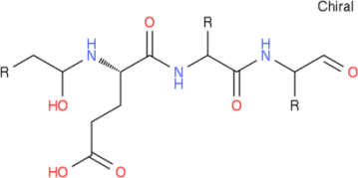
 |  | Cluster2 Bacteriocin  NC_002947.3 | N.A
 |  | Cluster3 Nrps  NC_002947.3 | BGC0000413_c1
 |  | Cluster4 Nrps  NC_002947.3 | BGC0000413_c1
 |  | Cluster5 Bacteriocin  NC_002947.3 | N.A
2 | F1 | - Cluster1 Bacteriocin  - NC_009512.1 | N.A | Structure from Cluster 2  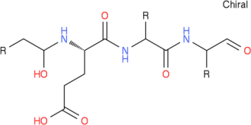  Structure from Cluster 3  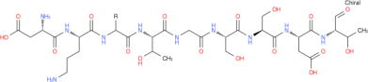
 |  | Cluster2 Nrps  NC_009512.1 | BGC0000413
 |  | Cluster3 Nrps  NC_009512.1 | BGC0000413
 |  | Cluster4 Bacteriocin  NC_009512.1 | -
 |  | - Cluster5 T1pks NC_009512.1 | BGC0000774
3 | GB-1 | Cluster1 Bacteriocin  NC_010322.1 | - | Structure from Cluster 3  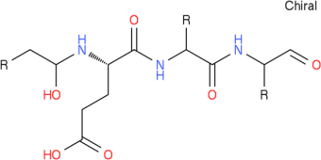  Structure from Cluster 4  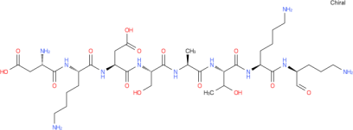
 |  | Cluster2 Bacteriocin  NC_010322.1 | -
 |  | Cluster3 Nrps  NC_010322.1 | Pyoverdine_biosynthetic_gene_cluster (8% of genes show similarity)  BGC0000413_c1
 |  | Cluster4 Nrps NC_010322.1 | Pyoverdine_biosynthetic_gene_cluster (5% of genes show similarity)  BGC0000413_c1
4 | W619 | - Cluster1 Bacteriocin  NC_010501.1 | - | Structure from Cluster 4  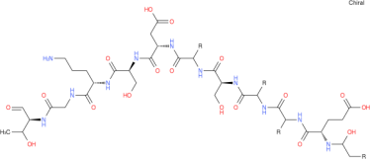
 |  | Cluster2 Bacteriocin NC_010501.1 | Oxazolomycin_biosynthetic_gene_cluster(6% of genes show similarity) BGC0001106_c1
 |  | Cluster3 Phenazine  - NC_010501.1 | -
 |  | - Cluster4 Nrps  NC_010501.1 | Pyoverdine_biosynthetic_gene_cluster (17% of genes show similarity)  BGC0000413_c1
5 | BIRD-1 | - Cluster1 Bacteriocin  CP002290.1 | - | Structure from Cluster 2  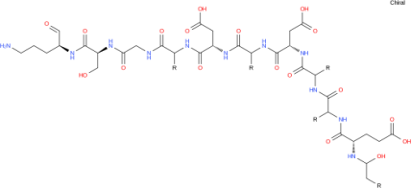
 |  | Cluster2 Nrps  CP002290.1 | Pyoverdine_biosynthetic_gene_cluster (17% of genes show similarity)  BGC0000413_c1
 |  | Cluster3 Bacteriocin  CP002290.1 | -
 |  | Cluster4 T1pks  CP002290.1 | O-antigen_ biosynthetic_gene_cluster (17% of genes show similarity)  BGC0000784_c1
6 | S16 | - Cluster1 Bacteriocin  NC_015733.1 | - | Structure from Cluster 2  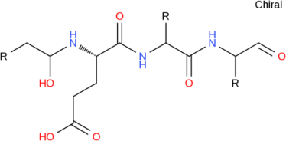  Structure from Cluster 3  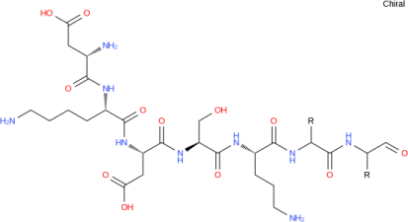
 |  | Cluster2 Nrps  NC_015733.1 | Pyoverdine_biosynthetic_gene_cluster (7% of genes show similarity)  BGC0000413_c1
 |  | - Cluster3 Nrps  NC_015733.1 | Pyoverdine_biosynthetic_gene_cluster (3% of genes show similarity)  BGC0000413_c1
7 | ND6 | - Cluster1 Bacteriocin  NC_017986.1 | - | Structure from Cluster 3  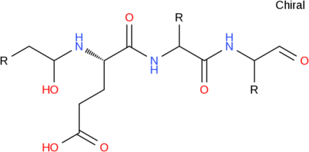  Structure from Cluster 4  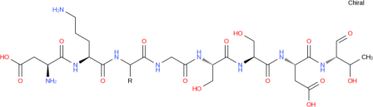
 |  | Cluster2 Bacteriocin  NC_017986.1 | -
 |  | Cluster3 Nrps  NC_017986.1 | Pyoverdine_biosynthetic_gene_cluster (6% of genes show similarity)  BGC0000413_c1
 |  | Cluster4 Nrps  NC_017986.1 | Pyoverdine_biosynthetic_gene_cluster (9% of genes show similarity)  BGC0000413_c1
8 | PC9 | - Cluster1 Bacteriocin  NC_019905.1 | - | Structure from Cluster 2  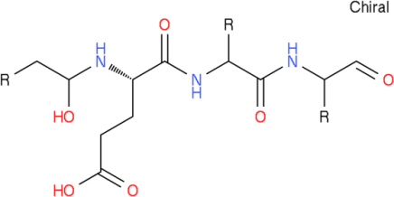  Structure from Cluster 3  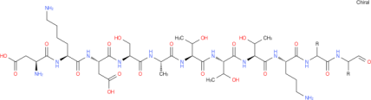
 |  | Cluster2 Nrps  NC_019905.1 | Pyoverdine_biosynthetic_gene_cluster (7% of genes show similarity)  BGC0000413_c1
 |  | - Cluster3 Nrps  NC_019905.1 | Pyoverdine_biosynthetic_gene_cluster (5% of genes show similarity)  BGC0000413_c1
9 | H8234 | - Cluster1 Bacteriocin  NC_021491.1 | - | Structure from Cluster 3  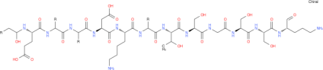
 |  | Cluster2 Bacteriocin  NC_021491.1 | -
 |  | Cluster3 Nrps  NC_021491.1 | Pyoverdine_biosynthetic_gene_cluster (19% of genes show similarity)  BGC0000413_c1
10 | NBRC 14164 | - Cluster1 Nrps  NC_021505.1 | Pyoverdine_biosynthetic_gene_cluster (5% of genes show similarity)  BGC0000413_c1 | Structure from Cluster 1  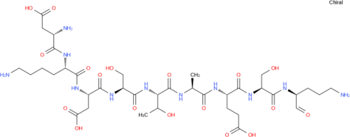  Structure from Cluster 2  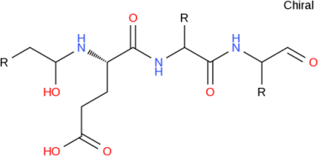
 |  | Cluster2 Nrps  NC_021505.1 | Pyoverdine_biosynthetic_gene_cluster (9% of genes show similarity)  BGC0000413_c1
 |  | - Cluster3 Bacteriocin  NC_021505.1 | -
 |  | Cluster4 Bacteriocin  NC_021505.1 | -
11 | DLL-E4 | - Cluster1 Bacteriocin  NZ_CP007620.1 | - | Structure from Cluster 2  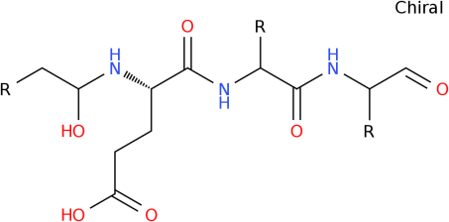  Structure from Cluster 3  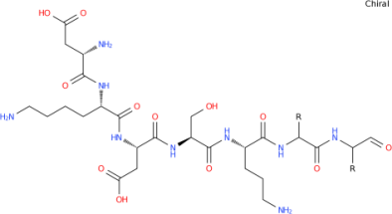
 |  | Cluster2 Nrps  NZ_CP007620.1 | Pyoverdine_biosynthetic_gene_cluster (7% of genes show similarity)  BGC0000413_c1
 |  | - Cluster3 Nrps  NZ_CP007620.1 | Pyoverdine_biosynthetic_gene_cluster (5% of genes show similarity)  BGC0000413_c1
12 | S13.1.2 | - Cluster1 Nrps  NZ_CP010979.1 | Pyoverdine_biosynthetic_gene_cluster (18% of genes show similarity)  BGC0000413_c1 | Structure from Cluster 1  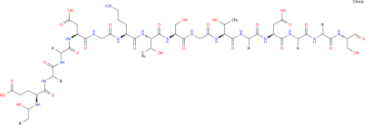  Structure from Cluster 4  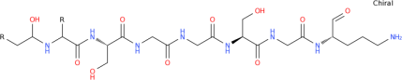
 |  | - Cluster2 Other  NZ_CP010979.1 | Pyoverdine_biosynthetic_gene_cluster (2% of genes show similarity)  BGC0000413_c1
 |  | - Cluster3 Bacteriocin  NZ_CP010979.1 | -
 |  | - Cluster4 Nrps  NZ_CP010979.1 | Pyoverdine_biosynthetic_gene_cluster (7% of genes show similarity)  BGC0000413_c1
 |  | Cluster5 T1pks  NZ_CP010979.1 | O-antigen_ biosynthetic_gene_cluster (22% of genes show similarity)  BGC0000784_c1
13 | S12 | - Cluster1 Nrps  NZ_CP009974.1 | Pyoverdine_biosynthetic_gene_cluster (18% of genes show similarity)  BGC0000413_c1 | Structure from Cluster 1  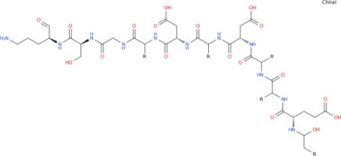
 |  | Cluster2 Bacteriocin  NZ_CP009974.1 | -
 |  | - Cluster3  - T1pks  NZ_CP009974.1 | O-antigen_ biosynthetic_gene_cluster (27% of genes show similarity)  BGC0000784_c1
 |  | - Cluster4 Bacteriocin  NZ_CP009974.1 | -
14 | DOT-T1E | - Cluster1 Nrps  CP003734.1 | Pyoverdine_biosynthetic_gene_cluster (2% of genes show similarity)  BGC0000413_c1 | Structure from Cluster 2  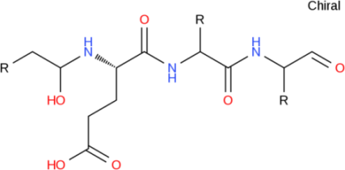  Structure from Cluster 3  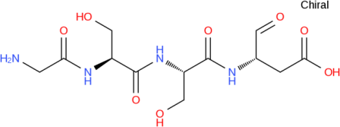
 |  | Cluster2 Nrps  CP003734.1 | Pyoverdine_biosynthetic_gene_cluster (1% of genes show similarity)  BGC0000413_c1
 |  | - Cluster3 Nrps  CP003734.1 | Pyoverdine_biosynthetic_gene_cluster (5% of genes show similarity)  BGC0000413_c1
 |  | - Cluster4 Bacteriocin  CP003734.1 | -
 |  | - Cluster5 Bacteriocin  CP003734.1 | -
15 | 1A00316 | - Cluster1 Bacteriocin  NZ_CP014343.1 | - | Structure from Cluster 2  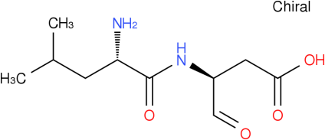  Structure from Cluster 3  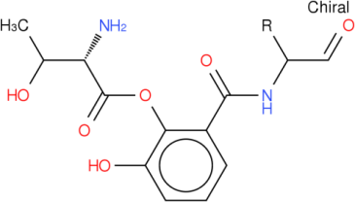  Structure from Cluster 4  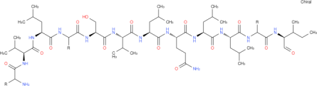
 |  | - Cluster2 Nrps  NZ_CP014343.1 | Xatholysin_biosynthetic_gene_cluster (100% of genes show similarity)  BGC0000463_c1
 |  | Cluster3 Nrps  NZ_CP014343.1 | Pseudomonine_biosynthetic_gene_cluster (100% of genes show similarity)  BGC0000410_c1
 |  | - Cluster4 Nrps  NZ_CP014343.1 | Entolysin_biosynthetic_gene_cluster (47% of genes show similarity)  BGC0000344_c1
 |  | - Cluster5 Nrps  NZ_CP014343.1 | Pyoverdine_biosynthetic_gene_cluster (13% of genes show similarity)  BGC0000413_c1
 |  | - Cluster6 Bacteriocin  NZ_CP014343.1 | Pseudopyronine_A_/_ Pseudopyronine _B_biosynthetic_gene_cluster (18% of genes show similarity)  BGC0001285_c1
 |  | Cluster7 Nrps  NZ_CP014343.1 | Pyoverdine_biosynthetic_gene_cluster (11% of genes show similarity)  BGC0000413_c1
Structure from Cluster 5
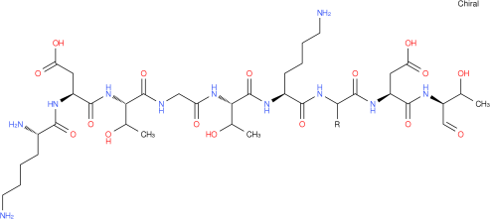
 |  | - Cluster8 Other  NZ_CP014343.1 | Mangotoxin_biosynthetic_gene_cluster (57% of genes show similarity)  BGC0000387_c1
16 | PC2 | Cluster1 Other  NZ_CP011789.1 | Mangotoxin_biosynthetic_gene_cluster (57% of genes show similarity)  BGC0000387_c1 | Structure from Cluster 2  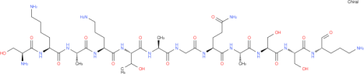  Structure from Cluster 3  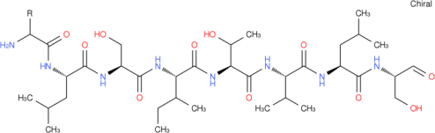  Structure from Cluster 4  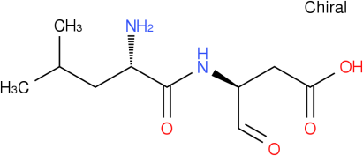  Structure from Cluster 5  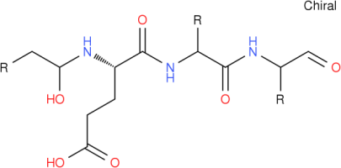
 |  | Cluster2 Nrps  NZ_CP011789.1 | Pyoverdine_biosynthetic_gene_cluster (10% of genes show similarity)  BGC0000413_c1
 |  | Cluster3 Nrps  NZ_CP011789.1 | WLIP_biosynthetic_gene_cluster (100% of genes show similarity)  BGC0000462_c2
 |  | Cluster4 Bacteriocin-Nrps  NZ_CP011789.1 | WLIP_biosynthetic_gene_cluster (83% of genes show similarity)  BGC0000462_c1
 |  | Cluster5 Nrps  NZ_CP011789.1 | Pyoverdine_biosynthetic_gene_cluster (4% of genes show similarity)  BGC0000413_c1
 |  | Cluster6 Butyrolactone-Hserlactone  NZ_CP011789.1 | -
17 | ABAC8 | Cluster1 Nrps  NZ_LKGZ01000010.1 | Pyoverdine_biosynthetic_gene_cluster (3% of genes show similarity)  BGC0000413_c1
 |  | Cluster2 Nrps  NZ_LKGZ01000011.1 | -
 |  | Cluster3 Nrps  NZ_LKGZ01000013.1 | -
 |  | Cluster4 Nrps  NZ_LKGZ01000016.1 | -
18 | ATH-43 | Cluster1 nrps  NZ_LBME01000004.1 | Pyoverdine_biosynthetic_gene_cluster (17% of genes show similarity)  BGC0000413_c1 | Structure from Cluster 1  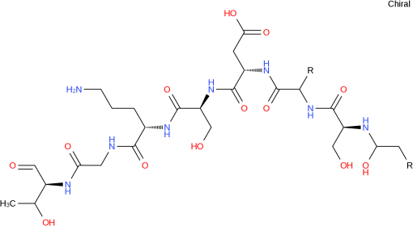
 |  | Cluster2 Bacteriocin  NZ_LBME01000005.1 | -
 |  | Cluster3 Bacteriocin NZ_LBME01000006.1 | -
 |  | Cluster4 Bacteriocin  NZ_LBME01000015.1 | -
19 | H | Cluster1 Bacteriocin  NZ_LFYQ01000023.1 | - | Structure from Cluster 2  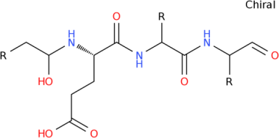  Structure from Cluster 3  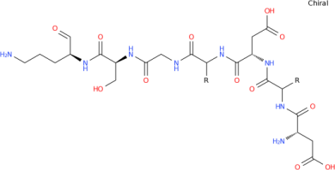
 |  | Cluster2  Nrps  NZ_LFYQ01000044.1 | Pyoverdine_biosynthetic_gene_cluster (5% of genes show similarity)  BGC0000413_c1
 |  | Cluster3 Nrps  NZ_LFYQ01000044.1 | Pyoverdine_biosynthetic_gene_cluster (16% of genes show similarity)  BGC0000413_c1
20 | JLR11 | Cluster1 Bacteriocin NZ_LDJF01000005.1 | - | Structure from Cluster 3  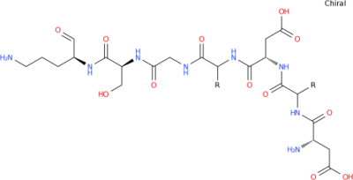  Structure from Cluster 4 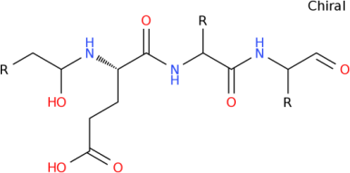
 |  | Cluster2  Bacteriocin  NZ_LDJF01000018.1 | -
 |  | Cluster3 nrps  NZ_LDJF01000027.1 | Pyoverdine_biosynthetic_gene_cluster (16% of genes show similarity)  BGC0000413_c1
 |  | Cluster4 nrps  NZ_LDJF01000027.1 | Pyoverdine_biosynthetic_gene_cluster (6% of genes show similarity)  BGC0000413_c1
21 | LF54 | Cluster1  Bacteriocin  NZ_AOUR02000011.1 | - | Structure from Cluster 3  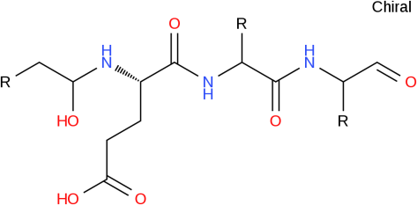  Structure from Cluster 4  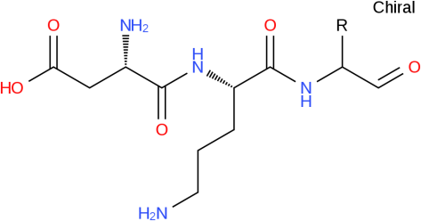  Structure from Cluster 5  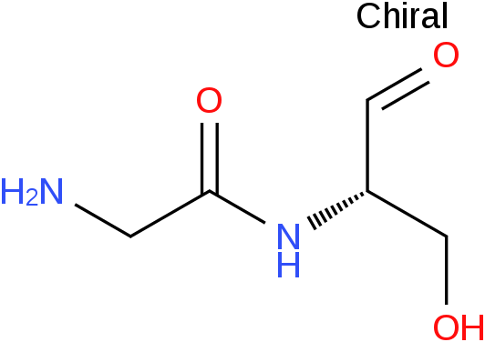  Structure from Cluster 6  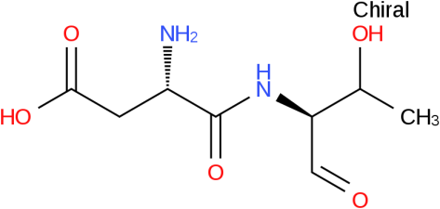
 |  | Cluster2 Bacteriocin  NZ_AOUR02000030.1 | -
 |  | Cluster3 nrps  NZ_AOUR02000098.1 | Pyoverdine_biosynthetic_gene_cluster (3% of genes show similarity)  BGC0000413_c1
 |  | Cluster4 nrps  NZ_AOUR02000109.1 | Pyoverdine_biosynthetic_gene_cluster (5% of genes show similarity)  BGC0000413_c1
 |  | Cluster5 nrps NZ_AOUR02000126.1 | Pyoverdine_biosynthetic_gene_cluster (3% of genes show similarity)  BGC0000413_c1
 |  | Cluster6 nrps  NZ_AOUR02000139.1 | Pyoverdine_biosynthetic_gene_cluster (7% of genes show similarity)  BGC0000413_c1
22 | PA14H7 | Cluster1 nrps NZ_KN639176.1 | Pyoverdine_biosynthetic_gene_cluster (16% of genes show similarity)  BGC0000413_c1 | Structure from Cluster 1  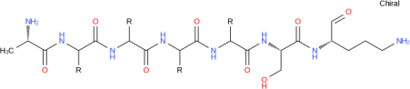  Structure from Cluster 3  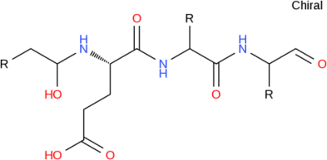
 |  | Cluster2 Other  NZ_KN639176.1 | Pyoverdine_biosynthetic_gene_cluster (3% of genes show similarity)  BGC0000413_c1
 |  | Cluster3 nrps  NZ_KN639176.1 | Pyoverdine_biosynthetic_gene_cluster (12% of genes show similarity)  BGC0000413_c1
 |  | Cluster4 Arylpolyene  NZ_KN639176.1 | APE_Vf_biosynthetic_gene_cluster (35% of genes show similarity)  BGC0000837_c1
 |  | Cluster5 Other NZ_KN639176.1 | Mangotoxin_biosynthetic_gene_cluster (57% of genes show similarity)  BGC0000387_c1
23 | PD1 | Cluster1 Hserlactone  NZ_JUHC01000011.1 | - | Structure from Cluster 3  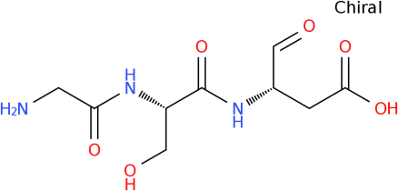  Structure from Cluster 5  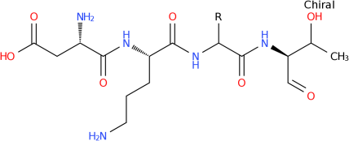
 |  | Cluster2 nrps  NZ_JUHC01000037.1 | Pyoverdine_biosynthetic_gene_cluster (3% of genes show similarity)  BGC0000413_c1
 |  | Cluster3 nrps  NZ_JUHC01000043.1 | Pyoverdine_biosynthetic_gene_cluster (4% of genes show similarity)  BGC0000413_c1
 |  | Cluster4 Bacteriocin  NZ_KN549113.1 | -
 |  | Cluster5 nrps NZ_KN549114.1 | Pyoverdine_biosynthetic_gene_cluster (4% of genes show similarity)  BGC0000413_c1
 |  | Cluster6 nrps NZ_KN549114.1 | Pyoverdine_biosynthetic_gene_cluster (9% of genes show similarity)  BGC0000413_c1 | Structure from Cluster 6  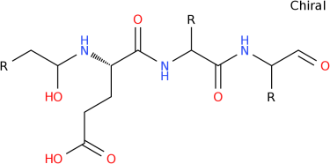
 |  | Cluster7 Bacteriocin NZ_KN549120.1 | -
 |  | Cluster8 T1pks NZ_KN549123.1 | O-antigen_biosynthetic_gene_cluster (35% of genes show similarity)  BGC0000781_c1
24 | BW11M1 | Cluster1 Bacteriocin NZ_LSLE01000001.1 | Pseudopyronine_A_/_pseudopyronine_B_biosynthetic_gene_cluster (18% of genes show similarity)  BGC0001285_c1 | Structure from Cluster 4  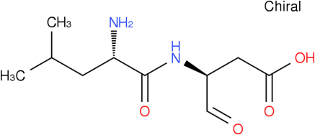  Structure from Cluster 5  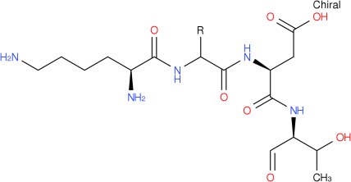  Structure from Cluster 6  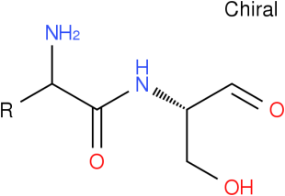  Structure from Cluster 7  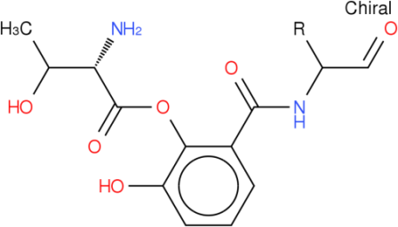  Structure from Cluster 8  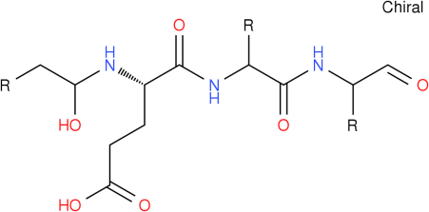  Structure from Cluster 9  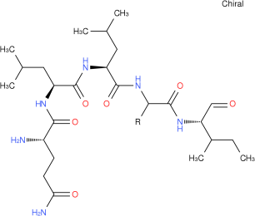  Structure from Cluster 11  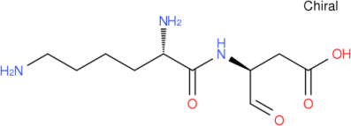
 |  | Cluster2 Bacteriocin NZ_LSLE01000002.1 | -
 |  | Cluster3 nrps NZ_LSLE01000005.1 | Entolysin_biosynthetic_gene_cluster (39% of genes show similarity)  BGC0000344_c1
 |  | Cluster4 nrps NZ_LSLE01000008.1 | Xantholysin_biosynthetic_gene_cluster (100% of genes show similarity)  BGC0000463_c1
 |  | Cluster5 nrps NZ_LSLE01000010.1 | Pyoverdine_biosynthetic_gene_cluster (3% of genes show similarity)  BGC0000413_c1
 |  | Cluster6 nrps NZ_LSLE01000018.1 | -
 |  | Cluster7 nrps NZ_LSLE01000021.1 | Pseudomonine_biosynthetic_gene_cluster (100% of genes show similarity)  BGC0000410_c1
 |  | Cluster8 nrps NZ_LSLE01000021.1 | Pyoverdine_biosynthetic_gene_cluster (11% of genes show similarity)  BGC0000413_c1
 |  | Cluster9 nrps NZ_LSLE01000025.1 | Xantholysin_biosynthetic_gene_cluster (100% of genes show similarity)  BGC0000463_c1
 |  | Cluster10 nrps NZ_LSLE01000035.1 | Orfamide_biosynthetic_gene_cluster (17% of genes show similarity)  BGC0000399_c1
 |  | Cluster11 nrps NZ_LSLE01000043.1 | Pyoverdine_biosynthetic_gene_cluster (10% of genes show similarity)  BGC0000413_c1
 |  | Cluster12 Others  NZ_LSLE01000045.1 | Mangotoxin_biosynthetic_gene_cluster (57% of genes show similarity)  BGC0000387_c1
 |  | Cluster13 nrps  NZ_LSLE01000055.1 | -
25 | 791_PPUT | Cluster1 Bacteriocin  NZ_JUST01000014.1 | - | Structure from Cluster 2  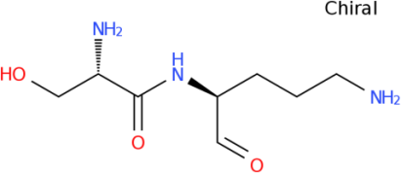  Structure from Cluster 6  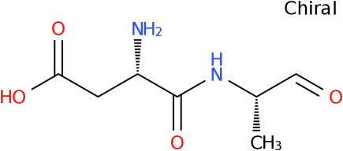
 |  | Cluster2 nrps NZ_JUST01000014.1 | -
 |  | Cluster3 nrps NZ_JUST01000224.1 | Pyoverdine_biosynthetic_gene_cluster (2% of genes show similarity)  BGC0000413_c1
 |  | Cluster4 Bacteriocin NZ_JUST01000259.1 | -
 |  | Cluster5 nrps NZ_JUST01000519.1 | -
 |  | Cluster6 nrps NZ_JUST01000529.1 | Pyoverdine_biosynthetic_gene_cluster (4% of genes show similarity)  BGC0000413_c1
 |  | Cluster7 nrps NZ_JUST01000548.1 | Pyoverdine_biosynthetic_gene_cluster (5% of genes show similarity)  BGC0000413_c1
26 | B001 | Cluster1 nrps NZ_CAED01000008.1 | Pyoverdine_biosynthetic_gene_cluster (8% of genes show similarity)  BGC0000413_c1 | Structure from Cluster 1  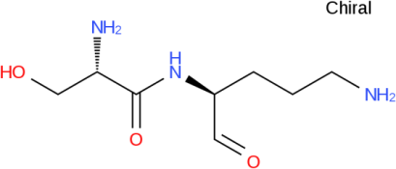
 |  | Cluster2 nrps NZ_CAED01000053.1 | Pyoverdine_biosynthetic_gene_cluster (6% of genes show similarity)  BGC0000413_c1
Structure from Cluster 3
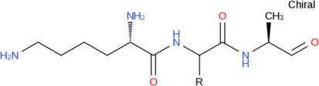

Structure from Cluster 5
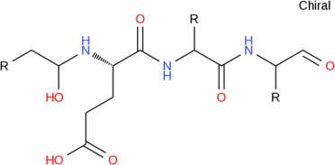
 |  | Cluster3 nrps NZ_CAED01000071.1 | Delftibactin_biosynthetic_gene_cluster (42% of genes show similarity)  BGC0000984_c1
 |  | Cluster4 Bacteriocin NZ_CAED01000149.1 | -
 |  | Cluster5 nrps NZ_CAED01000260.1 | Pyoverdine_biosynthetic_gene_cluster (2% of genes show similarity)  BGC0000413_c1
27 | B6-2 | Cluster1 Bacteriocin NZ_AGCS01000005.1 | - | Structure from Cluster 2  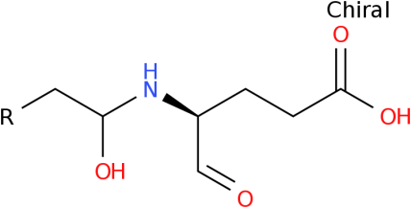  Structure from Cluster 3  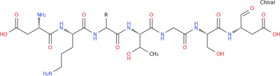
 |  | Cluster2 nrps NZ_AGCS01000009.1 | Pyoverdine_biosynthetic_gene_cluster (7% of genes show similarity)  BGC0000413_c1
 |  | Cluster3 nrps NZ_AGCS01000009.1 | Pyoverdine_biosynthetic_gene_cluster (9% of genes show similarity)  BGC0000413_c1
 |  | Cluster4 Bacteriocin NZ_AGCS01000013.1 | -
28 | CBB5 | Cluster1 Other NZ_JTEN01000003.1 | Mangotoxin_biosynthetic_gene_cluster (57% of genes show similarity)  BGC0000387_c1 | Structure from Cluster 2  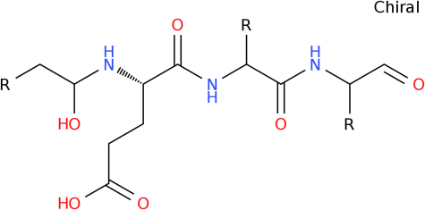  Structure from Cluster 5  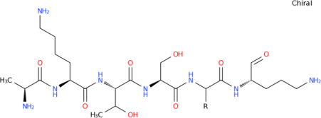
 |  | Cluster2 nrps NZ_JTEN01000021.1 | Pyoverdine_biosynthetic_gene_cluster (10% of genes show similarity)  BGC0000413_c1
 |  | Cluster3 Bacteriocin NZ_JTEN01000026.1 | -
 |  | Cluster4 Other NZ_JTEN01000028.1 | -
 |  | Cluster5 nrps NZ_JTEN01000083.1 | Pyoverdine_biosynthetic_gene_cluster (22% of genes show similarity)  BGC0000413_c1
 |  | Cluster6 T1pks NZ_JTEN01000116.1 | -
 |  | Cluster7 Arylpolyene NZ_JTEN01000129.1 | APE_Vf_biosynthetic_gene_cluster (40% of genes show similarity)  BGC0000837_c1
29 | CSV86 | Cluster1 Bacteriocin NZ_AMWJ01000017.1 | - | Structure from Cluster 3  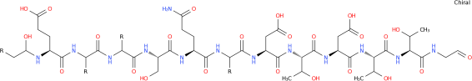
 |  | Cluster2 Arylpolyene NZ_AMWJ01000053.1 | APE_Vf_biosynthetic_gene_cluster (40% of genes show similarity)  BGC0000837_c1
 |  | Cluster3 nrps  NZ_AMWJ01000133.1 | Pyoverdine_biosynthetic_gene_cluster (9% of genes show similarity)  BGC0000413_c1
 |  | Cluster4 Other  NZ_AMWJ01000197.1 | Mangotoxin_biosynthetic_gene_cluster (57% of genes show similarity)  BGC0000387_c1
30 | HB4184 | Cluster1 nrps NZ_LKKT01000070.1 | Pyoverdine_biosynthetic_gene_cluster (10% of genes show similarity)  BGC0000413_c1 | Structure frm Cluster 1  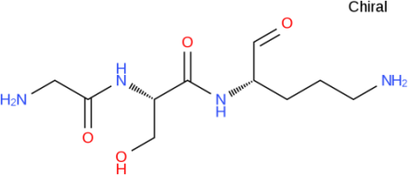  Structure from Cluster 2  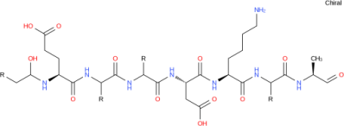
 |  | Cluster2 nrps  NZ_LKKT01000076.1 | Pyoverdine_biosynthetic_gene_cluster (11% of genes show similarity)  BGC0000413_c1
 |  | Cluster3 Bacteriocin  NZ_LKKT01000085.1 | -
 |  | Cluster4 nrps  NZ_LKKT01000116.1 | Cyanopeptin_biosynthetic_gene_cluster (75% of genes show similarity)  BGC0000331_c1
31 | HB13667 | Cluster1 nrps  NZ_LKKS01000006.1 | Pyoverdine_biosynthetic_gene_cluster (5% of genes show similarity)  BGC0000413_c1 | Structure from Cluster 1  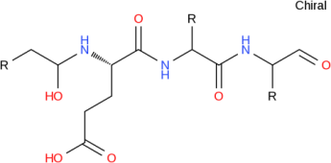  Structure from Cluster 4  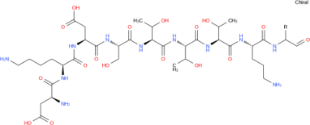
 |  | Cluster2 Bacteriocin  NZ_LKKS01000017.1 | -
 |  | Cluster3 Bacteriocin  NZ_LKKS01000070.1 | -
 |  | Cluster4 nrps NZ_LKKS01000137.1 | Pyoverdine_biosynthetic_gene_cluster (4% of genes show similarity)  BGC0000413_c1
32 | Idaho | Cluster1 Bacteriocin  NZ_AGFJ01000011.1 | - | Structure from Cluster 2  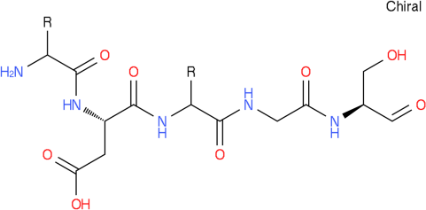  Structure from Cluster 8  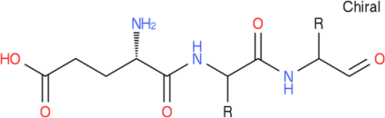
 |  | Cluster2 nrps NZ_AGFJ01000212.1 | Pyoverdine_biosynthetic_gene_cluster (1% of genes show similarity)  BGC0000413_c1
 |  | Cluster3 nrps NZ_AGFJ01000428.1 | Pyoverdine_biosynthetic_gene_cluster (1% of genes show similarity)  BGC0000413_c1
 |  | Cluster4 Bacteriocin  NZ_AGFJ01000473.1 | -
 |  | Cluster5 nrps  NZ_AGFJ01000703.1 | -
 |  | Cluster6 nrps  NZ_AGFJ01000727.1 | -
 |  | Cluster7 Other  NZ_AGFJ01000835.1 | Pyoverdine_biosynthetic_gene_cluster (11% of genes show similarity)  BGC0000413_c1
 |  | Cluster8 nrps NZ_AGFJ01000838.1 | Pyoverdine_biosynthetic_gene_cluster (2% of genes show similarity)  BGC0000413_c1
33 | IOFA1 | Cluster1 Bacteriocin NZ_LGRH01000003.1 | - | Structure from Cluster 3  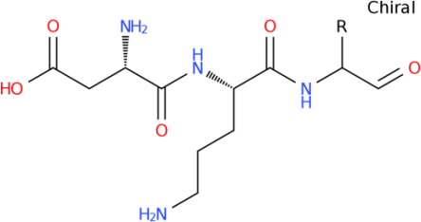  Structure from Cluster 4  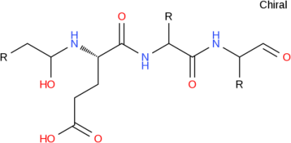
 |  | Cluster2 Bacteriocin  NZ_LGRH01000007.1 | -
 |  | Cluster3 nrps NZ_LGRH01000032.1 | Pyoverdine_biosynthetic_gene_cluster (5% of genes show similarity)  BGC0000413_c1
 |  | Cluster4 nrps NZ_LGRH01000059.1 | Pyoverdine_biosynthetic_gene_cluster (3% of genes show similarity)  BGC0000413_c1
 |  | Cluster5 nrps NZ_LGRH01000079.1 | -
 |  | Cluster6 nrps NZ_LGRH01000095.1 | Nostopeptolide_biosynthetic_gene_cluster (25% of genes show similarity)  BGC0001028_c1
 |  | Cluster7 nrps NZ_LGRH01000104.1 | -
34 | KF703 | Cluster1 Bacteriocin NZ_BBQL01000026.1 | - | Structure from Cluster 2  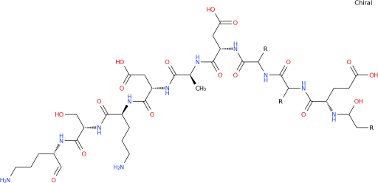  Structure from Cluster 2  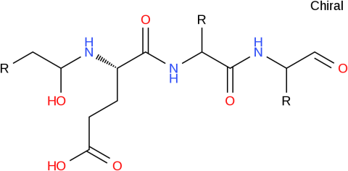  Structure from Cluster 4  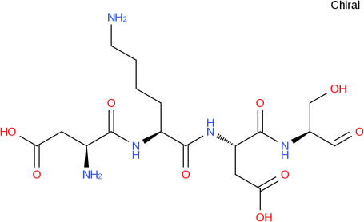
 |  | Cluster2 nrps NZ_BBQL01000046.1 | Pyoverdine_biosynthetic_gene_cluster (19% of genes show similarity)  BGC0000413_c1
 |  | Cluster3 Bacteriocin NZ_BBQL01000063.1 | -
35 | KG-4 | Cluster1 Phenazine NZ_AYRY01000007.1 | -
 |  | Cluster2 nrps  NZ_AYRY01000008.1 | Pyoverdine_biosynthetic_gene_cluster (8% of genes show similarity)  BGC0000413_c1
 |  | Cluster3 Bacteriocin NZ_AYRY01000014.1 | -
 |  | Cluster4 nrps  NZ_AYRY01000014.1 | Pyoverdine_biosynthetic_gene_cluster (2% of genes show similarity)  BGC0000413_c1
 |  | Cluster5 nrps NZ_AYRY01000058.1 | -
36 | LS46 | Cluster1 nrps  NZ_ALPV02000004.1 | Pyoverdine_biosynthetic_gene_cluster (3% of genes show similarity)  BGC0000413_c1 | Structure from Cluster 1  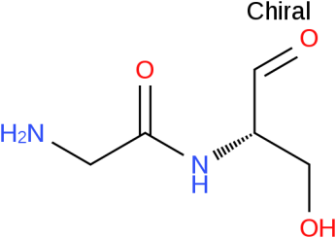  Structure from Cluster 6  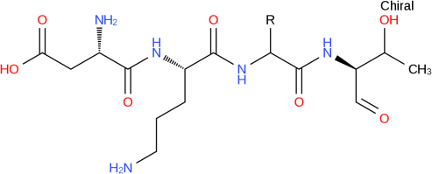  Structure from Cluster 7  Structure from Cluster 9  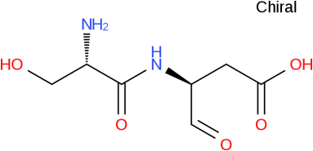
 |  | Cluster2 Bacteriocin NZ_ALPV02000010.1 | -
 |  | Cluster3 Bacteriocin  NZ_ALPV02000011.1 | -
 |  | Cluster4 nrps  NZ_ALPV02000012.1 | Pyoverdine_biosynthetic_gene_cluster (4% of genes show similarity)  BGC0000413_c1
 |  | Cluster5 T1pks  NZ_ALPV02000014.1 | Lipopolysaccharide_biosynthetic_gene_cluster (25% of genes show similarity)  BGC0000773_c1
 |  | Cluster6 nrps  NZ_ALPV02000017.1 | Pyoverdine_biosynthetic_gene_cluster (4% of genes show similarity)  BGC0000413_c1
 |  | Cluster7 nrps NZ_ALPV02000017.1 | Pyoverdine_biosynthetic_gene_cluster (7% of genes show similarity)  BGC0000413_c1
 |  | Cluster8 Bacteriocin NZ_ALPV02000017.1 | -
 |  | Cluster9 nrps NZ_ALPV02000030.1 | Pyoverdine_biosynthetic_gene_cluster (2% of genes show similarity)  BGC0000413_c1
37 | MC4-5222 | Cluster1 nrps NZ_JOJW01000483.1 | Pyoverdine_biosynthetic_gene_cluster (1% of genes show similarity)  BGC0000413_c1 | Structure from Cluster 1  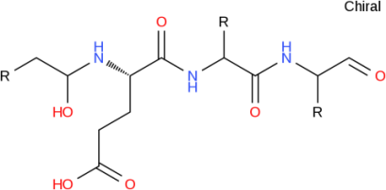  Structure from Cluster 3  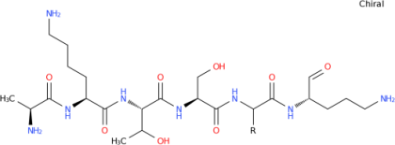
 |  | Cluster2 Lantipeptide-Bacteriocin NZ_JOJW01000588.1 | -
 |  | Cluster3 nrps NZ_JOJW01000601.1 | Pyoverdine_biosynthetic_gene_cluster (7% of genes show similarity)  BGC0000413_c1
 |  | Cluster4 T1pks NZ_JOJW01000708.1 | -
 |  | Cluster5 Arylpolyene NZ_JOJW01000740.1 | APE_Vf_biosynthetic_gene_cluster (20% of genes show similarity)  BGC0000837_c1
 |  | Cluster6 Other NZ_JOJW01000803.1 | -
 |  | Cluster7 Bacteriocin NZ_JOJW01000991.1 | -
38 | MTCC5279 | Cluster1 Other NZ_AMZE01000004.1 | - | Structure from Cluster 5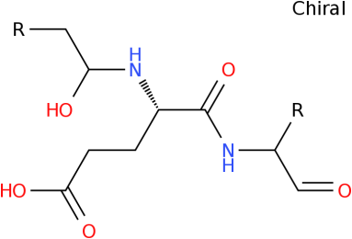
 |  | Cluster2 Arylpolyene NZ_AMZE01000012.1 | APE_Vf_biosynthetic_gene_cluster (25% of genes show similarity)  BGC0000837_c1
 |  | Cluster3 nrps NZ_AMZE01000033.1 | Pyoverdine_biosynthetic_gene_cluster (3% of genes show similarity)  BGC0000413_c1
 |  | Cluster4 Bacteriocin NZ_AMZE01000035.1 | -
 |  | Cluster5 nrps NZ_AMZE01000040.1 | Pyoverdine_biosynthetic_gene_cluster (7% of genes show similarity)  BGC0000413_c1
 |  | Cluster6 nrps NZ_AMZE01000064.1 | Pyoverdine_biosynthetic_gene_cluster (9% of genes show similarity)  BGC0000413_c1
 |  | Cluster7 nrps NZ_AMZE01000123.1 | -
 |  | Cluster8 nrps NZ_AMZE01000131.1 | -
 |  | Cluster9 nrps NZ_AMZE01000142.1 | -
39 | OUS82 | Cluster1 Bacteriocin NZ_AZBL01000047.1 | - | Structure from Cluster 2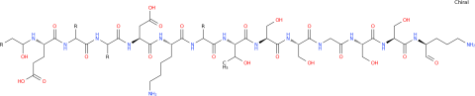
 |  | Cluster2 nrps NZ_AZBL01000064.1 | Pyoverdine_biosynthetic_gene_cluster (18% of genes show similarity)  BGC0000413_c1
 |  | Cluster3 Bacteriocin NZ_AZBL01000100.1 | -
40 | PCL1760 | Cluster1 Bacteriocin NZ_LIYM01000002.1 | - | Structure from Cluster 4  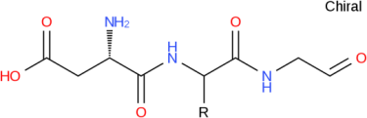  Structure from Cluster 5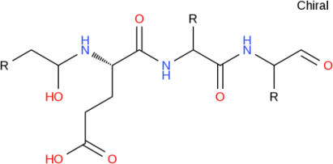
 |  | Cluster2 Bacteriocin NZ_LIYM01000007.1 | -
 |  | Cluster3 T1pks NZ_LIYM01000009.1 | O-antigen_biosynthetic_gene_cluster (22% of genes show similarity)  BGC0000784_c1
 |  | Cluster4 nrps NZ_LIYM01000010.1 | Pyoverdine_biosynthetic_gene_cluster (13% of genes show similarity)  BGC0000413_c1
 |  | Cluster5 nrps NZ_LIYM01000044.1 | Pyoverdine_biosynthetic_gene_cluster (3% of genes show similarity)  BGC0000413_c1
41 | S610 | Cluster1 Arylpolyene NZ_AYJQ01000001.1 | APE_Vf_biosynthetic_gene_cluster (40% of genes show similarity)  BGC0000837_c1 | Structure from Cluster 2  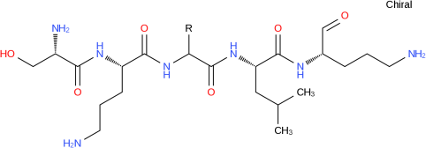  Structure from Cluster 5  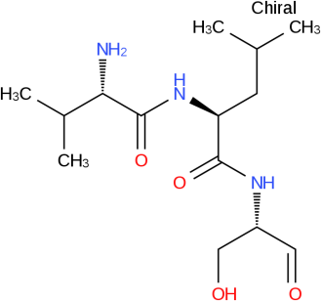  Structure from Cluster 6  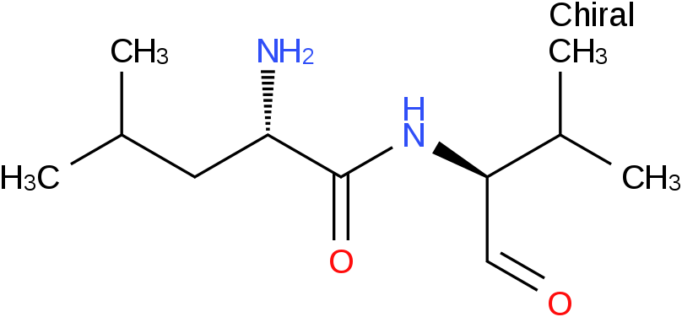  Structure from Cluster 7 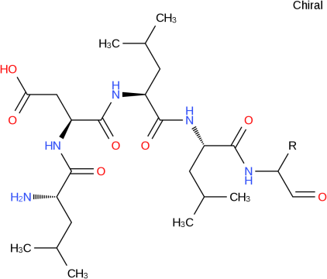  Structure from Cluster 8  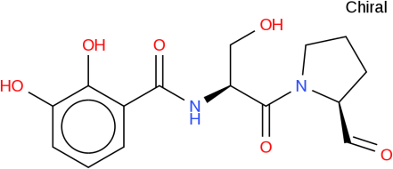  Structure from Cluster 9  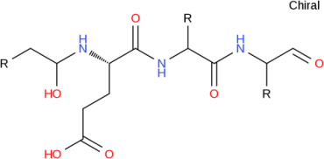
 |  | Cluster2 nrps NZ_AYJQ01000010.1 | Pyoverdine_biosynthetic_gene_cluster (2% of genes show similarity)  BGC0000413_c1
 |  | Cluster3 nrps NZ_AYJQ01000018.1 | Pyoverdine_biosynthetic_gene_cluster (3% of genes show similarity)  BGC0000413_c1
 |  | Cluster4 Terpene NZ_AYJQ01000027.1 | Carotenoid_biosynthetic_gene_cluster (85% of genes show similarity)  BGC0000642_c1
 |  | Cluster5 nrps NZ_AYJQ01000048.1 | -
 |  | Cluster6 nrps NZ_AYJQ01000049.1 | -
 |  | Cluster7 nrps NZ_AYJQ01000050.1 | Orfamide_biosynthetic_gene_cluster (40% of genes show similarity)  BGC0000398_c1
 |  | Cluster8 nrps NZ_AYJQ01000058.1 | Vulnibactin_biosynthetic_gene_cluster (12% of genes show similarity)  BGC0000460_c1
 |  | Cluster9 nrps NZ_AYJQ01000065.1 | Pyoverdine_biosynthetic_gene_cluster (6% of genes show similarity)  BGC0000413_c1
42 | SF1 | Cluster1 Bacteriocin NZ_LDPF01000002.1 | - | Structure from Cluster 2  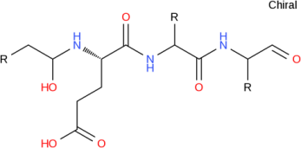  Structure from Cluster 3  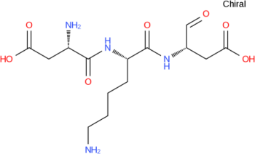
 |  | Cluster2 nrps NZ_LDPF01000033.1 | -
 |  | Cluster3 nrps NZ_LDPF01000042.1 | Pyoverdine_biosynthetic_gene_cluster (2% of genes show similarity)  BGC0000413_c1
43 | SJ3 | Cluster1 nrps NZ_AXDX01000183.1 | Pyoverdine_biosynthetic_gene_cluster (7% of genes show similarity)  BGC0000413_c1 | Structure from Cluster 1 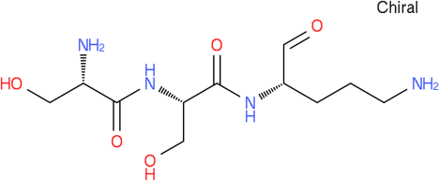
 |  | Cluster2 Bacteriocin NZ_AXDX01000326.1 | -
 |  | Cluster3 nrps  NZ_AXDX01000364.1 | Pyoverdine_biosynthetic_gene_cluster (2% of genes show similarity)  BGC0000413_c1
44 | SJTE-1 | Cluster1 Bacteriocin  NZ_AKCL01000027.1 | - | Structure from Cluster 3  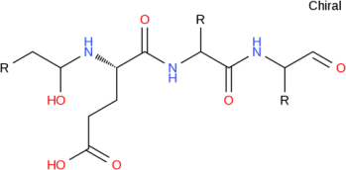  Structure from Cluster 4  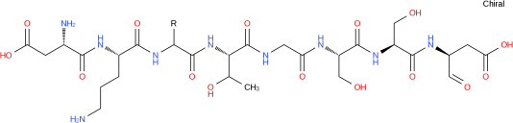
 |  | Cluster2 Bacteriocin NZ_AKCL01000161.1 | -
 |  | Cluster3 nrps NZ_AKCL01000175.1 | Pyoverdine_biosynthetic_gene_cluster (3% of genes show similarity)  BGC0000413_c1
 |  | Cluster4 nrps NZ_AKCL01000177.1 | Pyoverdine_biosynthetic_gene_cluster (9% of genes show similarity)  BGC0000413_c1
45 | SQ1 | Cluster1 nrps NZ_JTCJ01000026.1 | Pyoverdine_biosynthetic_gene_cluster (2% of genes show similarity)  BGC0000413_c1 | Structure from Cluster 6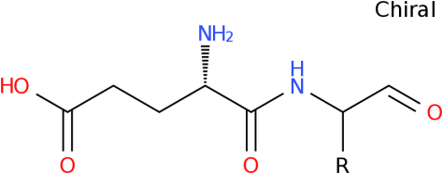
 |  | Cluster2 Bacteriocin NZ_JTCJ01000080.1 | -
 |  | Cluster3 nrps NZ_JTCJ01000102.1 | Pyoverdine_biosynthetic_gene_cluster (2% of genes show similarity)  BGC0000413_c1
 |  | Cluster4 nrps NZ_JTCJ01000113.1 | -
 |  | Cluster5 Bacteriocin NZ_JTCJ01000122.1 | -
 |  | Cluster6 nrps NZ_JTCJ01000162.1 | -
 |  | Cluster7 nrps NZ_JTCJ01000193.1 | -
 |  | Cluster8 nrps NZ_JTCJ01000304.1 | Pyoverdine_biosynthetic_gene_cluster (1% of genes show similarity)  BGC0000413_c1
 |  | Cluster9 nrps NZ_JTCJ01000377.1 | Pyoverdine_biosynthetic_gene_cluster (4% of genes show similarity)  BGC0000413_c1
 |  | Cluster10 nrps NZ_JTCJ01000568.1 | -
 |  | Cluster11 Phenazine NZ_JTCJ01000681.1 | -
46 | T2-2 | Cluster1 Other NZ_JALX01000036.1 | - | Structure from Cluster3  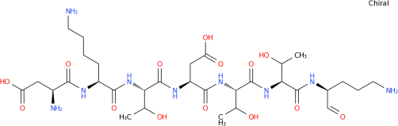  Structure from Cluster4
 |  | Cluster2 nrps NZ_JALX01000040.1 | -
 |  | Cluster3 nrps NZ_JALX01000096.1 | Pyoverdine_biosynthetic_gene_cluster (10% of genes show similarity)  BGC0000413_c1
 |  | Cluster4 nrps NZ_JALX01000127.1 | Pyoverdine_biosynthetic_gene_cluster (3% of genes show similarity)  BGC0000413_c1
47 | TRO1 | Cluster1 nrps NZ_APBQ01000003.1 | Pyoverdine_biosynthetic_gene_cluster (4% of genes show similarity)  BGC0000413_c1 | Structure from Cluster 1  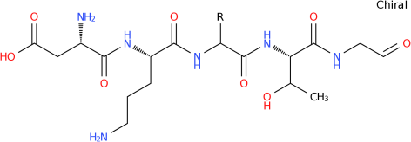  Structure from Cluster 4  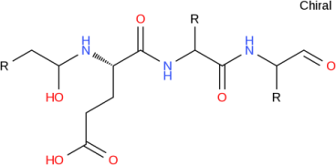
 |  | Cluster2 Bacteriocin NZ_APBQ01000004.1 | -
 |  | Cluster3 Bacteriocin NZ_APBQ01000057.1 | -
 |  | Cluster4 nrps NZ_APBQ01000108.1 | Pyoverdine_biosynthetic_gene_cluster (3% of genes show similarity)  BGC0000413_c1
 |  | Cluster5 T1pks NZ_APBQ01000148.1 | -
 |  | Cluster6 nrps NZ_APBQ01000161.1 | -
 |  | Cluster7 nrps NZ_APBQ01000169.1 | -
 |  | Cluster8 Bacteriocin  NZ_APBQ01000207.1 | -
48 | UASWS0946 | Cluster1 nrps NZ_JXOG01000093.1 | Delftibactin_biosynthetic_gene_cluster (28% of genes show similarity)  BGC0000984_c1 | Structure from Cluster 3  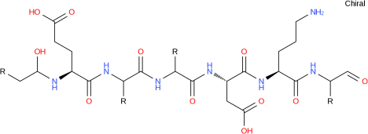  Structure from Cluster 5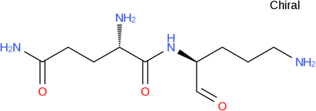
 |  | Cluster2 Hserlactone NZ_JXOG01000161.1 | -
 |  | Cluster3 nrps NZ_JXOG01000175.1 | Pyoverdine_biosynthetic_gene_cluster 17% of genes show similarity)  BGC0000413_c1
 |  | Cluster4 Ectoine NZ_JXOG01000181.1 | -
 |  | Cluster5 nrps NZ_JXOG01000182.1 | Pyoverdine_biosynthetic_gene_cluster (11% of genes show similarity)  BGC0000413_c1
49 | W15Oct28 | Cluster1 nrps NZ_JENB01000006.1 | Putisolvin_biosynthetic_gene_cluster (100% of genes show similarity)  BGC0000411_c1 | Structure from Cluster 1  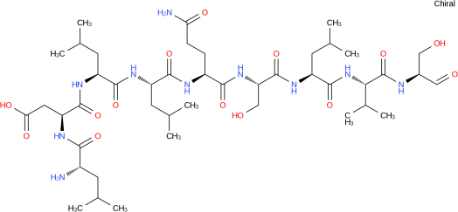  Structure from Cluster 3  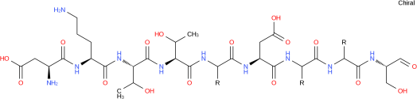  Structure from Cluster 5
 |  | Cluster2 nrps NZ_JENB01000023.1 | Safracin_biosynthetic_gene_cluster (40% of genes show similarity)  BGC0000421_c1
 |  | Cluster3 nrps NZ_JENB01000032.1 | Pyoverdine_biosynthetic_gene_cluster (11% of genes show similarity)  BGC0000413_c1
 |  | Cluster4 Bacteriocin NZ_JENB01000034.1 | -
 |  | Cluster5 nrps NZ_JENB01000063.1 | Pyoverdine_biosynthetic_gene_cluster (5% of genes show similarity)  BGC0000413_c1
 |  | Cluster6 Bacteriocin NZ_JENB01000085.1 | -
50 | YKD221 | Cluster1 nrps NZ_BBNC01000011.1 | Pyoverdine_biosynthetic_gene_cluster (4% of genes show similarity)  BGC0000413_c1 | Structure from Cluster 4  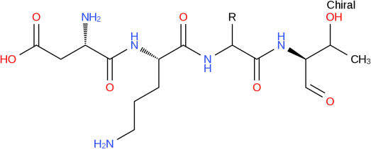  Structure from Cluster 5
 |  | Cluster2 Bacteriocin NZ_BBNC01000024.1 | -
 |  | Cluster3 Bacteriocin NZ_BBNC01000032.1 | -
 |  | Cluster4 nrps NZ_BBNC01000042.1 | Pyoverdine_biosynthetic_gene_cluster (4% of genes show similarity)  BGC0000413_c1
 |  | Cluster5 nrps NZ_BBNC01000043.1 | Pyoverdine_biosynthetic_gene_cluster (4% of genes show similarity)  BGC0000413_c1
 |  | Cluster6 T1kps NZ_BBNC01000050.1 | Lipopolysaccharide_biosynthetic_gene_cluster (17% of genes show similarity)  BGC0000774_c1
 |  | Cluster7 nrps NZ_BBNC01000071.1 | Pyoverdine_biosynthetic_gene_cluster (4% of genes show similarity)  BGC0000413_c1
51 | FDAARGOS_121 | Cluster1 Other | - | Structure from Cluster 2  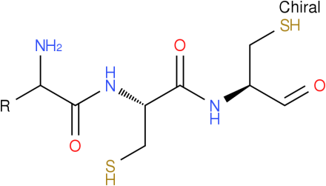  Structure from Cluster 6  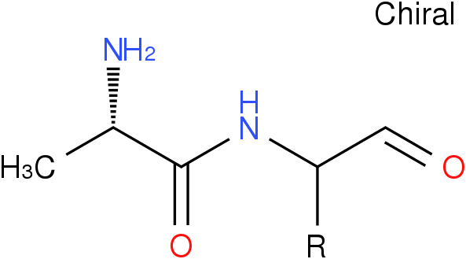  Structure from Cluster 7  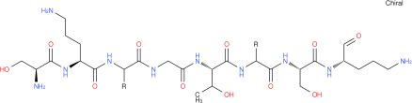  Structure from Cluster 8  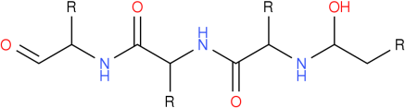  Structure from Cluster 10  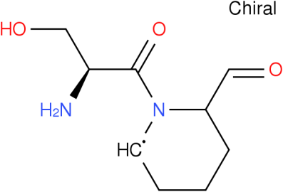
 |  | Cluster2 Phenazine-Nrps | Pyocheline_ biosynthetic_gene_cluster (100% of genes show similarity)  BGC0000412_c1
 |  | Cluster3 Other | Pyoverdine_biosynthetic_gene_cluster (2% of genes show similarity)  BGC0000413_c1
 |  | Cluster4 Hserlactone | -
 |  | Cluster5 Phenazine | Pyocyanine_biosynthetic_gene_cluster (100% of genes show similarity)  BGC0000936_c1
 |  | Cluster6 Nrps | 2-amino-4-methoxy-trans-3-butenoic_acid_biosynthetic_gene_cluster (100% of genes show similarity)  BGC0000287_c1
 |  | Cluster7 Nrps | Pyoverdine_biosynthetic_gene_cluster (23% of genes show similarity)  BGC0000413_c1
 |  | Cluster8 Nrps | Pyoverdine_biosynthetic_gene_cluster (14% of genes show similarity)  BGC0000413_c1
 |  | Cluster9 Bacteriocin | N.A
 |  | Cluster10 Nrps | N.A
 |  | Cluster11 Hserlactone | N.A
52 | MR3 | Cluster1 Bacteriocin | N.A
N.A = not available
Table S3: The Bacteriocin type metabolites identified for different P. putida strains.
 | Strains | AOI* | Gene start and End position | Type | Blast hit in bactericin database (BAGL3)
1 | KT2440 | AOI_1;orf009 | 5000-6421 | Class III | Zoocin_A[6e-23]
 |  | AOI_2;orf006 | 5000-7258 | Class III | Colicin[3e-36]
2 | F1 | AOI_1;orf009 | 5000-6421 | Class III | Zoocin_A[6e-23]
 |  | AOI_2;orf009 | 7295-7438 | - | Bottromycin
3 | GB-1 | AOI_1;orf008 | 5000-6736 | Class III | Carocin_D[2e-53]
4 | BIRD-1 | AOI_1;orf009 | 5000-6370 | Class III | Zoocin_A[4e-23]
5 | S16 | AOI_1;orf011 | 5000-7192 | Class III | Colicin[2e-30]
6 | ND6 | AOI_1;orf009 | 5000-7258 | Class III | Colicin[2e-36]
 |  | AOI_2;orf009 | 5000-6370 | Class III | Zoocin_A[5e-23]
7 | PC9 | AOI_1;orf009 | 5000-7015 | Class III | Colicin_E9[3e-32]
 |  | AOI_1;orf012 | 5000-7258 | Class III | Colicin[2e-38]
8 | H8234 | AOI_1;smallORF_31 | 7517-7687 |  | Bottromycin
9 | DLL-E4 | AOI_1;orf013 | 5000-7192 | Class III | Colicin[2e-30]
10 | S13.1.2 | AOI_1;orf012 | 5000-7321 | Class III | Colicin[2e-37]
11 | S12 | AOI_1;orf005 | 5000-6421 | Class III | Zoocin_A[7e-23]
 |  | AOI_2;orf010 | 5000-6268 | Class III | Colicin[8e-39]
12 | DOT-T1E | AOI_1;smallORF_44 | 1323-1424 |  | Bottromycin
 |  | AOI_2;orf009 | 5000-6370 | Class III | Zoocin_A[5e-23]
13 | 1A00316 | AOI_1;smallORF_37 | 2921-3040 |  | Microcin
 |  | AOI_2;orf008 | 5000-5830 | Class III | Putidacin_L1[0.0]
14 | PC2 | AOI_1;orf005 | 5000-6259 | Class II | Propionicin_SM1[4e-08]
15 | ABAC8 | AOI_1;orf011 | 5000-5461 | Class II | Propionicin_SM1[2e-08]
16 | OUS82 | AOI_1;smallORF_51 | 928-1092 |  | Bottromycin
17 | PCL1760 | AOI_1;orf012 | 5000-6268 | Class III | Colicin[8e-39]
18 | SJTE-1 | AOI_1;orf008 | 5000-7258 | Class III | Colicin[2e-36]
* AOI= Area of Interest
Table S4: The NRPs/PKs metabolites annotated for P. putida strains.
S.No | Strains | Clusters | Clusters Type | Product | Homologous Clusters
1 | 1A00316 | 1 | Nrp | Unknown | Fusaricidin
 |  | 2 | Nrp | Unknown | Plipastatin
 |  | 3 | Nrp | Unknown | Arthrofactin
 |  | 4 | Nrp | Unknown | Acinetobactin
 |  | 5 | Nrp | Unknown | Entolysin
 |  | 6 | Unknown thiotemplated cluster type | Unknown | Enacyloxin
 |  | 7 | Nrp | Unknown | Pyoverdin
 |  | 8 | Nrp | Unknown | Spumigin
2 | KT2440 | 1 | T1Pks | Unknown | Fusaricidin
 |  | 2 | Unknown thiotemplated cluster type | Unknown | Plipastatin
 |  | 3 | Nrp | Unknown | Thailandamide
 |  | 4 | Nrp | Unknown | Pyoverdin
 |  | 5 | Nrp | Unknown | Spumigin
3 | F1 | 1 | Nrp | Unknown | Spumigin
 |  | 2 | Nrp | Unknown | Paenibacterin
 |  | 3 | Unknown thiotemplated cluster type | Unknown | Plipastatin
 |  | 4 | T1Pks | Unknown | Fusaricidin
 |  | 5 | T1Pks | Propionic acid | Nostophycin
4 | GB-1 | 1 | T1Pks | Unknown | Fusaricidin
 |  | 2 | Unknown thiotemplated cluster type | Unknown | Asukamycin
 |  | 3 | Nrp | Unknown | Spumigin
 |  | 4 | Nrp | Unknown | Pyoverdin
5 | W619 | 1 | T1Pks | Unknown | Fusaricidin
 |  | 2 | Penicillin | Unknown | Penicillin
 |  | 3 | Unknown thiotemplated cluster type | Unknown | Plipastatin
 |  | 4 | Nrp | Unknown | Lysobactin
6 | BIRD-1 | 1 | Nrp | Unknown | Polymyxin
 |  | 2 | Unknown thiotemplated cluster type | Unknown | Asukamycin
 |  | 3 | T1Pks | Unknown | Fusaricidin
 |  | 4 | T1Pks | Unknown | Nostophycin
7 | S16 | 1 | T1Pks | Unknown | Fusaricidin
 |  | 2 | Unknown thiotemplated cluster type | Unknown | Plipastatin
 |  | 3 | Nrp | Unknown | Spumigin
 |  | 4 | Nrp | Unknown | Pyoverdin
8 | ND6 | 1 | Unknown thiotemplated cluster type | Unknown | Plipastatin
 |  | 2 | T1Pks | Unknown | Fusaricidin
 |  | 3 | Nrp | Unknown | Spumigin
 |  | 4 | Nrp | Unknown | Pyoverdin
9 | PC9 | 1 | T1Pks | Unknown | Fusaricidin
 |  | 2 | Unknown thiotemplated cluster type | Unknown | Plipastatin
 |  | 3 | Nrp | Unknown | Spumigin
 |  | 4 | Nrp | Unknown | Pyoverdin
10 | H8234 | 1 | T1Pks | Unknown | Fusaricidin
 |  | 2 | Nrp | Unknown | Tolaasin
11 | NBRC-14164 | 1 | Nrp | Unknown | Pyoverdin
 |  | 2 | Nrp | Unknown | Spumigin
 |  | 3 | Unknown thiotemplated cluster type | Unknown | Asukamycin
 |  | 4 | T1Pks | Unknown | Fusaricidin
12 | DLL-E4 | 1 | T1Pks | Unknown | Fusaricidin
 |  | 2 | Unknown thiotemplated cluster type | Unknown | Plipastatin
 |  | 3 | Nrp | Unknown | Spumigin
 |  | 4 | Nrp | Unknown | Pyoverdin
13 | S13.1.2 | 1 | Nrp | Unknown | Sessilin
 |  | 2 | Unknown thiotemplated cluster type | Unknown | Asukamycin
 |  | 3 | Nrp | Unknown | Thanamycin
 |  | 4 | T1Pks | Unknown | Fusaricidin
 |  | 5 | T1Pks | Propionic acid | Nostophycin
14 | S12 | 1 | Nrp | Unknown | Polymyxin
 |  | 2 | T1Pks | Propionic acid | Nostophycin
 |  | 3 | T1Pks | Unknown | Fusaricidin
 |  | 4 | Unknown thiotemplated cluster type | Unknown | Plipastatin
15 | DOT-T1E | 1 | Nrp | Aspartic acid (s)-form | Pyoverdin
 |  | 2 | Unknown thiotemplated cluster type | Unknown | Plipastatin
 |  | 3 | Nrp | Unknown | Spumigin
 |  | 4 | Nrp | Unknown | Anabaenopeptilide
 |  | 5 | Nrp | Unknown | Hassallidin
 |  | 6 | T1Pks | Unknown | Fusaricidin
16 | PC2 | 1 | T1Pks | Unknown | Fusaricidin
 |  | 2 | Nrp | Unknown | Gramicidin
 |  | 3 | Nrp | Unknown | Tolaasin
 |  | 4 | Nrp | Unknown | Massetolide
 |  | 5 | Unknown thiotemplated cluster type | Unknown | Plipastatin
 |  | 6 | Nrp | Unknown | Spumigin
17 | ATH-43 | 1 | Nrp | Unknown | Enterocin
18 | H | 1 | Nrp | Unknown | Thailandamide
19 | JLR11 | 1 | Nrp | Unknown | Thailandamide
20 | PA14H7 | 1 | T1Pks | Unknown | Fusaricidin
 |  | 2 | Nrp | Unknown | Pyoverdin
 |  | 3 | Nrp | Unknown | Pyoverdin
21 | CSV86 | 1 | Unknown thiotemplated cluster type | Unknown | Plipastatin
22 | FDAARGOS_121 | 1 | Nrp | Unknown | Pyochelin
 |  | 2 | T1Pks | Unknown | Ravidomycin
 |  | 3 | Nrp | Unknown | Teixobactin
 |  | 4 | Nrp | Unknown | Pyoverdin
 |  | 5 | Nrp | Unknown | Spumigin
 |  | 6 | Nrp | Unknown | Octacosamicin
 |  | 7 | T1Pks | Unknown | Fusaricidin
 |  | 8 | Nrp | Unknown | Tyrocydine
23 | LS46 | 1 | Nrp | Unknown | Pyoverdin
 |  | 2 | Nrp | Unknown | Spumigin

