**Supplementary Information**

**Graphene: A Building foundation for efficient plasmonic SERS device**

**Section 1**: Fabrication of plasmonic devices

**Section 2**: Calculation of SERS enhancement factor

**Section 3**: Raman mapping of 3-MBA chemisorbed over AsPrep_GAg and As250_GAg devices

**Section 4**: Optimized geometry and HOMO-LUMO representation of 3-MBA and3-MBA attached with silver

**Section 1**: **Fabrication of plasmonic devices**

The schematic diagram of SERS device is shown in **Figure S1**. SLG coated over SiO2/Si substrate was used over which 6 nm Ag thin film was deposited by means of sputtering technique. Two sets of samples were made from this sample. One set was used as an AsPrep sample whereas the other was annealed at 250 °C with dwell time of 1h. Thereafter, the device was immersed in the molecular solution for 30 min for chemisorption. The sample was then rinsed with the solvent to wash out the extra molecules, which were not attached directly with the metal surface. The sample is then ready for spectroscopic characterization.

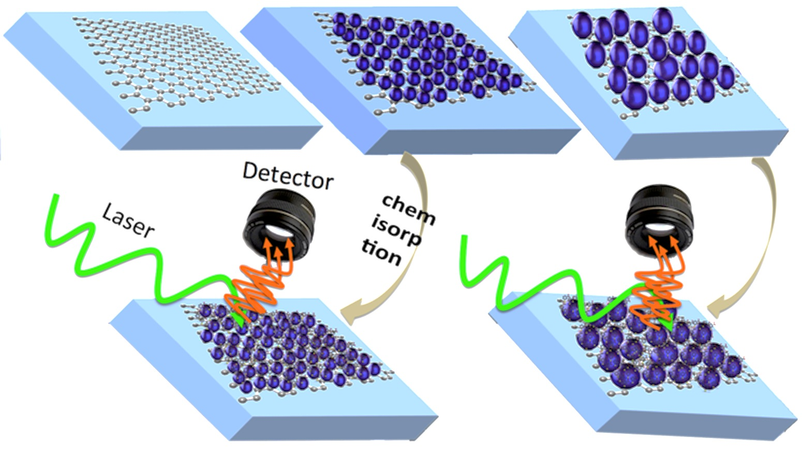

**Figure S1**: Schematic diagram of SERS device preparation

**Section 2: Calculation of SERS enhancement factor**

Rd6G was chemisorbed over AsPrep_GAg and As250_GAg devices. SERS spectra of Rd6G on the graphene based devices and on flat Ag substrate were shown in **Figure 3a**. The laser power was fixed for all the measurements. However, the integration time and Raman intensity for each measurement can be found in the graph. The active area (*hot-spot*) for AsPrep_GAg and for As250_GAg, considering the gap of 8 nm and 15 nm, is 50.24 and 490.63 nm2, respectively. The number of *hot-spots* for AsPrep_GAg and for As250_GAg within 1 m diameter is 6.28 × 102 and 1.36 × 102, respectively. SERS enhancement factor for both samples with respect to flat Ag surface can be estimated using:



where, *I*, *t*, *P* and *A* are Raman intensity, integration time, laser power and active area, respectively. *SERS* and *Ref* in the subscript represent the measurements over graphene based SERS substrates and over flat Ag substrate, respectively. In the denominator, *N* is the number of *hot-spots* in an area of diameter 1 m.

Inserting all the values mentioned above, the enhancement factor for AsPrep_GAg and As250_GAg is 2.1 × 106 and 7.2 × 106, respectively, with respect to the flat Ag substrate.

**Section 3: Raman mapping of 3-MBA chemisorbed over AsPrep_GAg and As250_GAg devices**

3-MBA was chemisorbed over AsPrep_GAg and As250_GAg samples. SERS mapping measurements were performed for both samples. Raman mapping analysis for bands centred at 1001 cm-1 (**Figure S2a** and **S2a’**) and 1585 cm-1 (**Figure S2b** and **S2b’**) were shown in **Figure S2**. SERS spectra at different positions in the mapping area are shown in **Figure S2c** and **Figure S2c’**. Various Raman bands for 3-MBA can be clearly observed in the range of 400-1800 cm-1. A small band at 2675 cm-1 is related to the graphene present underneath.

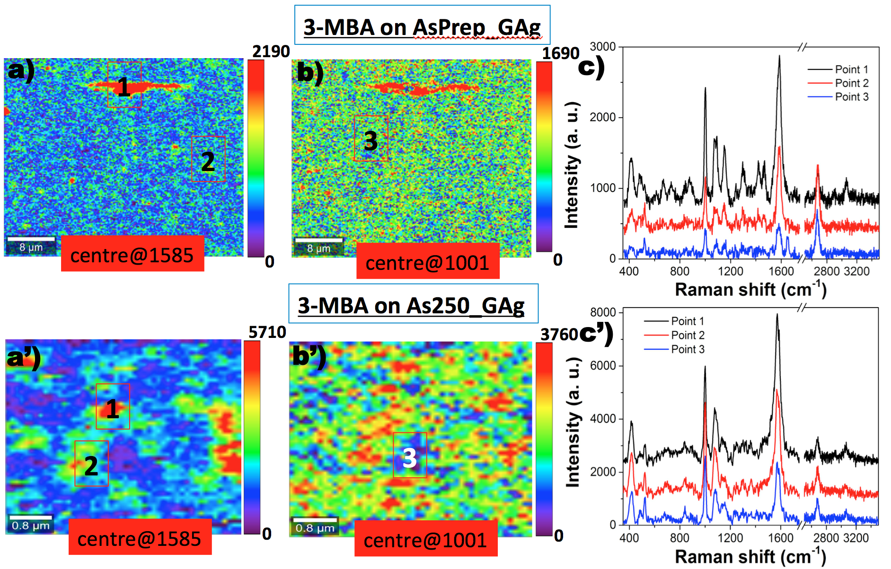

**Figure S2**: 2D Raman mapping of 3-MBA molecule deposited over Ag coated graphene samples. a) Raman mapping analysis for 3MBA-AsPrep_GAg device, centred at 1585 cm-1, b) at 1001 cm-1 and c) Raman spectra of 3-MBA at different points. Raman mapping analysis and Raman spectra for 3MBA-As250_GAg are shown in a’,b’,c’).

**Section 4**: **Optimized geometry and HOMO-LUMO representation of 3-MBA and3-MBA attached with silver**

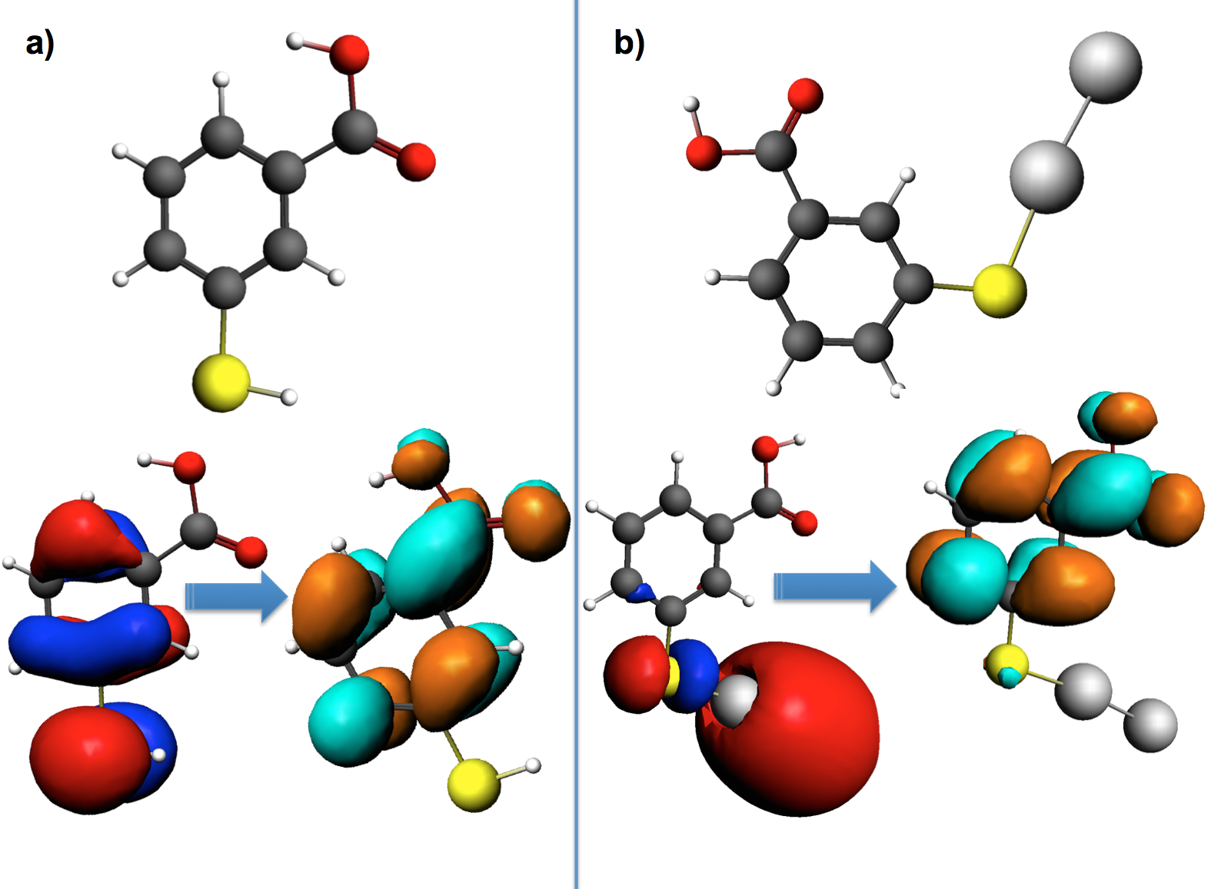

**Figure S3**: Optimized geometry of 3-MBA (a) and 3-MBA attached with silver (b) are shown. In the lower panel, HOMO to LUMO configurations for both molecules is reported. The energy difference from HOMO to LUMO for 3-MBA and 3-MBA attached with silver is 3.17 eV (0.100767 Hartee) and 1.28 eV (0.047157 Hartee), respectively.