**Supplementary Data**

Included here are supporting materials to the main manuscript from pilot sample from the same source population and additional illustrations (i.e. tables or figures) that could not be included in the main manuscript due to restricted number of allowable illustrations

**1.** In a pilot sample of 40 subjects, we explored the pattern of performances over the course of IGT tasks and found that 25 out of 40 subjects (~ 60%) performed randomly, i.e. their net scores from block 1 through 5 neither increased nor decreased steadily. Supplementary Figure 1 is a spaghetti plot of 10 randomly selected subjects out of the 40, showing 3 people with demonstrable learning curve and 2 people with negative slope; the rest 5 people performed randomly.



**Supplementary Figure 1:** Performances over 5 Blocks of IGT Task in a Random Sample of 10 HIV+ Subjects. 3 people with demonstrable learning curve and 2 people with negative slope; the rest 5 people performed randomly. The dashed lines represent individual performances over Blocks 1-5. The solid Black line is the mean scores for all participants on Blocks 1-5.

**2.** One of the more advanced approaches for modeling IGT performance is the growth curve approach (Stockard, O’Brien, & Peters, 2007). In the simplest form of this approach, known as linear growth curve (or random effect-coefficient) model, the mean performance at the individual level, known as the random effect or intercept, and a slope parameter that represents whether an individual’s performance improves or worsens over time are modeled (Supplementary Figure 2A). This can further be extended to quadratic (Supplementary Figure 2B) or even higher-order growth curve models. These random effects (i.e. intercept and slopes) are also latent factors. Using IGT data from the 100 HIV+ patients in this study, we estimated the intercept and slope parameters from simple growth curve model and examined the residual fit. As shown in Supplementary Table 1 the mean estimate for slope (i.e. learning curve) is -0.268, with P value of 0.191, which is not significant at P < 0.05 level. The chi-square test for global fit comparing this model to a saturated model (i.e. a model with zero degrees of freedom) is significant (P=0.011), suggesting that this model is disappointing (Supplementary Table 1). Even the less stringent criteria of random fit, i.e. RMSEA, CFI and SRMR) are not encouraging.

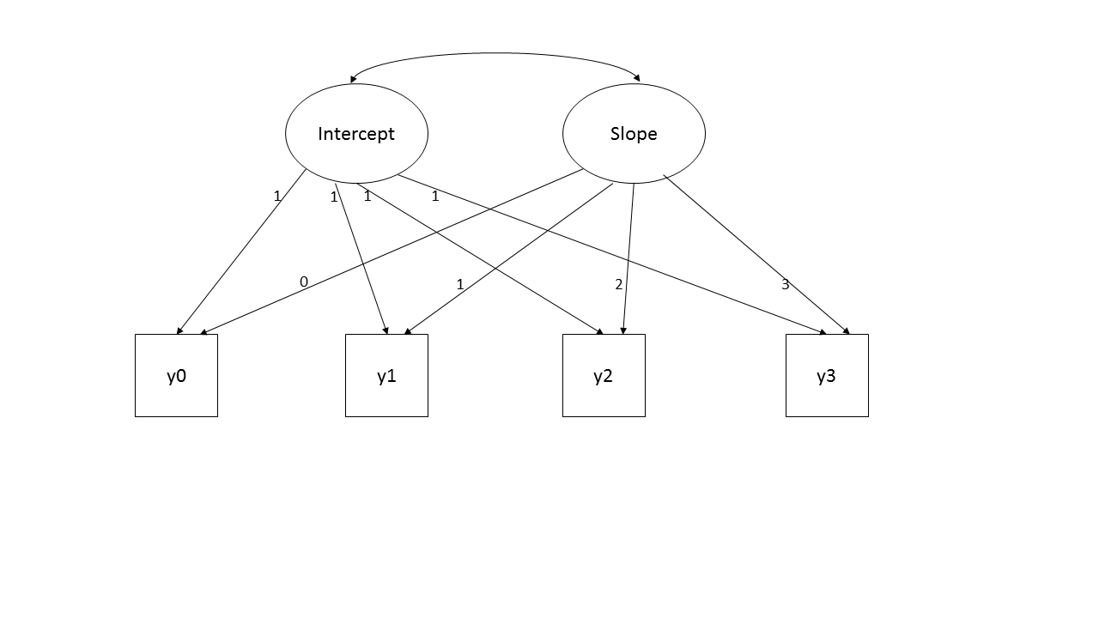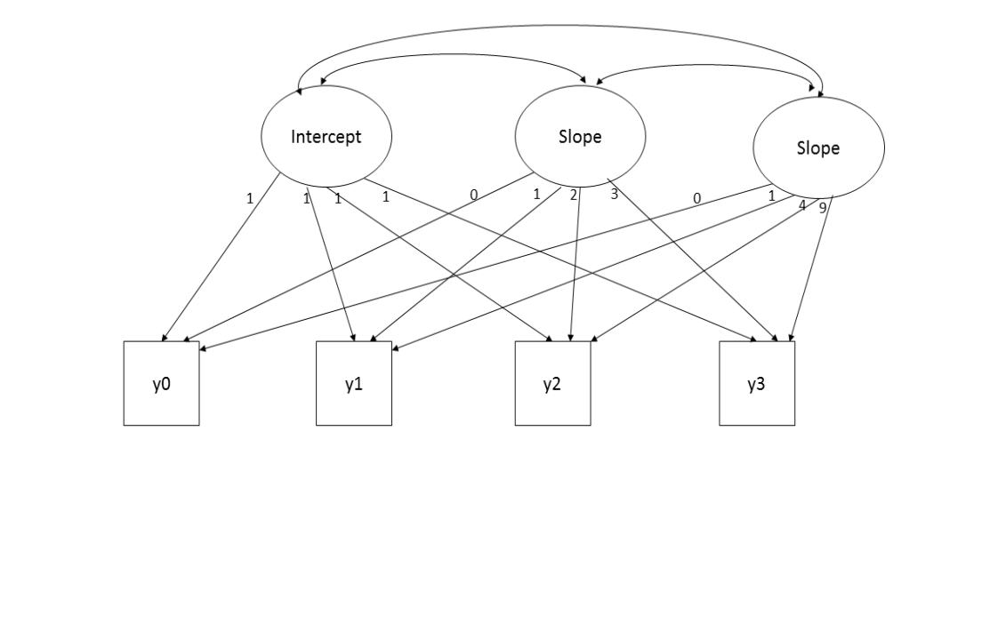

B

A

**Supplementary Figure 2:** Simple Growth Curve and Quadratic Growth Curve Models for Examining Learning Component of IGT Performance.

|  |  |  |  |
| --- | --- | --- | --- |
| Parameters | Mean | 95% CI | P |
| Estimation |  |  |  |
| Intercept | -1.238 | -2.075, -0.402 | 0.004 |
| Slope | -0.268 | -0.669, 0.134 | 0.191 |
| Covariance (Intercept/slope) | 2.277 | 0.022, 4.533 | 0.048 |
| Fit |  |  |  |
| *Χ2* (10) | 23.027 |  | 0.011 |
| RMSEA | 0.115 |  |  |
| CFI | 0.867 |  |  |
| SRMR | 0.079 |  |  |

**Supplementary Table 1:** Estimation of Linear Growth Curve for Net Scores on IGT

**3.** We also estimated coefficients (i.e. mean effects) of linear and quadratic terms of quadratic growth curve. As shown in Supplementary Table 2, none of these slopes are statistically significant

|  |  |  |  |
| --- | --- | --- | --- |
| Models | Coefficient | 95% CI | P value |
| QUADRATIC |  |  |  |
| Net1-5 | 0.314 | -1.584, 2.212 | 0.743 |
| (Net1-5)2 | -0.098 | -0.416, 0.220 | 0.542 |

**4.** In the entire sample of 100 HIV+ subjects, we examined the pairwise correlations between Net scores 1-5. As shown in Supplementary Table 3, the correlation between Net 1 and Net 2 is 0.045, which is the lowest correlation between adjacent blocks.Net 1 did not have correlations up to 0.3 with any block. On the other hand, with the exception of a correlation of 0.1816 between Net 2 and Net 5, all other paired correlations were greater than 0.4.

|  |  |  |  |  |  |
| --- | --- | --- | --- | --- | --- |
|  | net1 | net2 | net3 | net4 | net5 |
|  |  |  |  |  |  |
| net1 | 1 |  |  |  |  |
| net2 | 0.0405 | 1 |  |  |  |
| net3 | 0.2562 | 0.4386 | 1 |  |  |
| net4 | 0.2148 | 0.4558 | 0.5167 | 1 |  |
| net5 | 0.2154 | 0.1816 | 0.4298 | 0.5146 | 1 |

**Supplementary Table 2:** Results of coefficients for the linear and quadratic terms of the quadratic growth curve model.

**Supplementary Table 3:** Results of Pairwise Correlations between Net 1 to Net 5 Scores.