A New Approach to Protection and Conservation of Cites-Listed Species: DNA Barcoding of Parrots in Nigeria.

Supplementary File

Sample IDs | Scientific name | English name | Genbank No
1 | Psittacula krameri | Rose-ringed parakeet | MH844578
2 | Psittacus erithacus | Grey parrot | MH882517
3 | Poicephalus senegalus | Senegal parrot | MH844579

Table A: List of sequenced parrot species collected and their GenBank accession numbers.

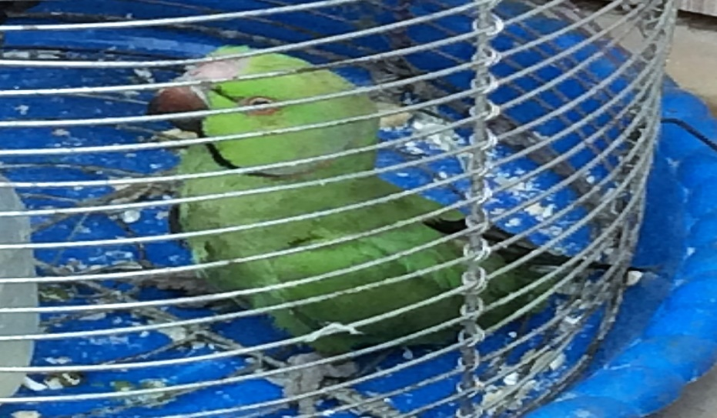

Figure 1: Psittacula krameri.

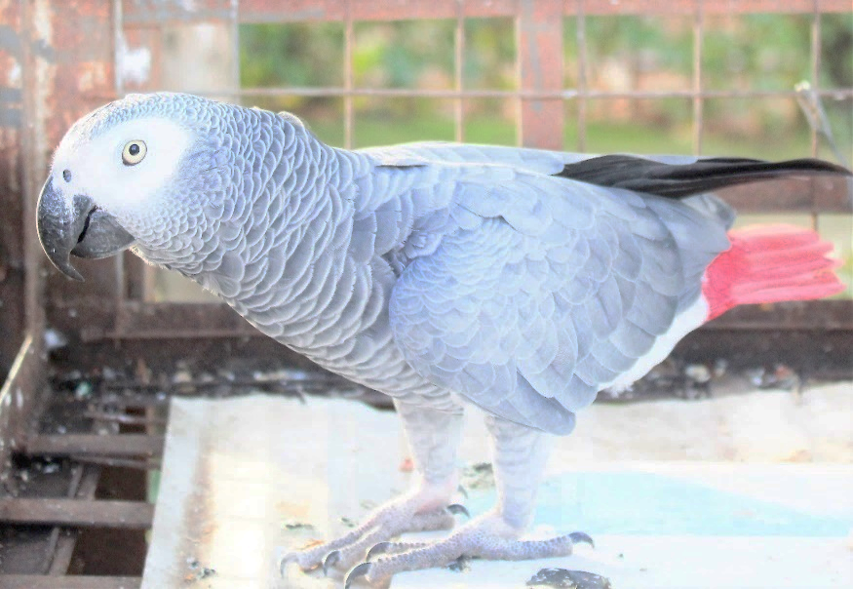

Figure 2: Psittacus erithacus.

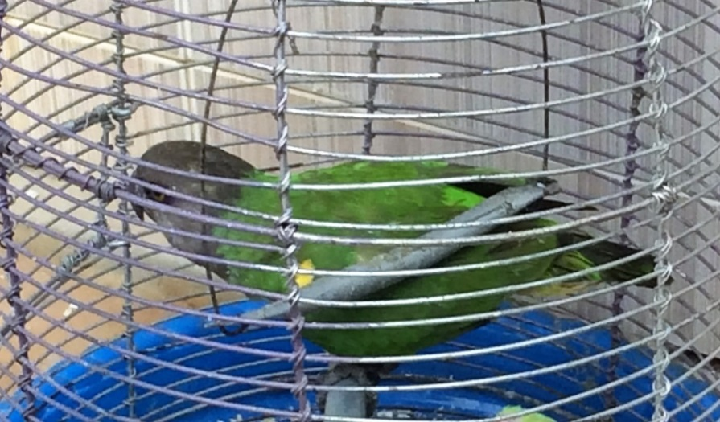

Figure 3: Poicephalus senegalus.

