Supporting information for

Characteristics of Autophagy induced by Enterovirus71 (EV71) Viral Protein
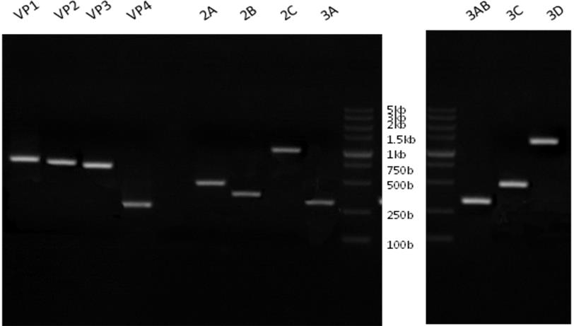

Figure S1. 11 virus protein expression of positive plasmids were confirmed by PCR
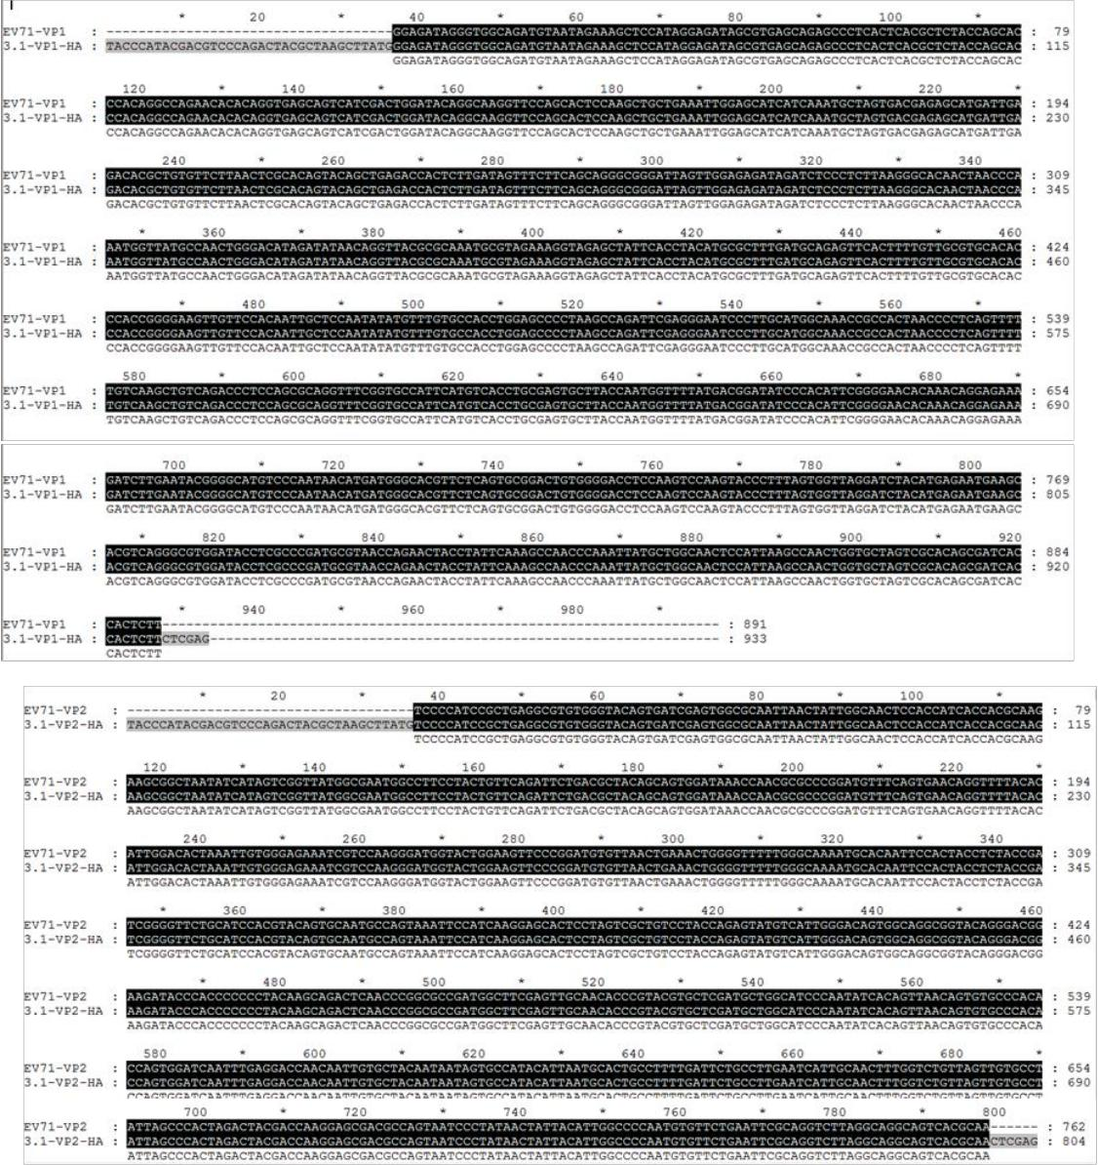

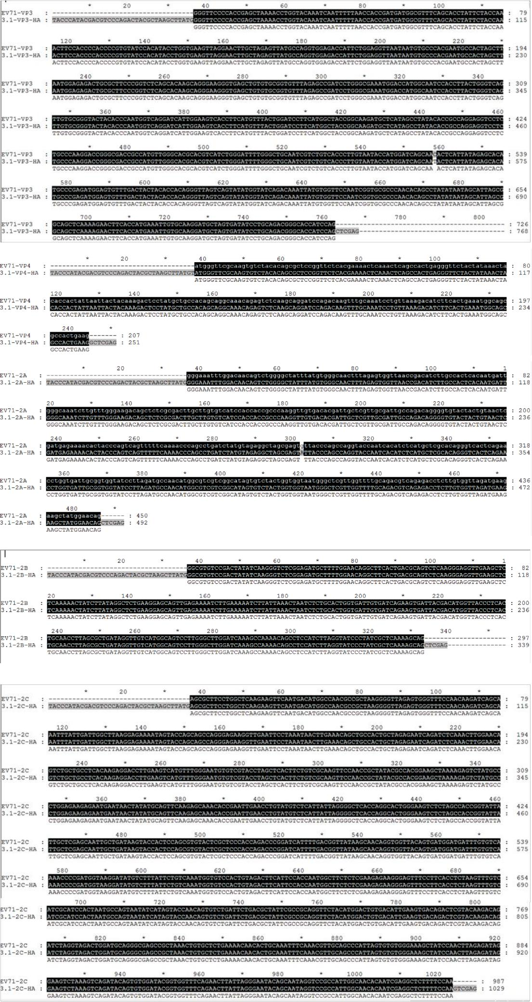

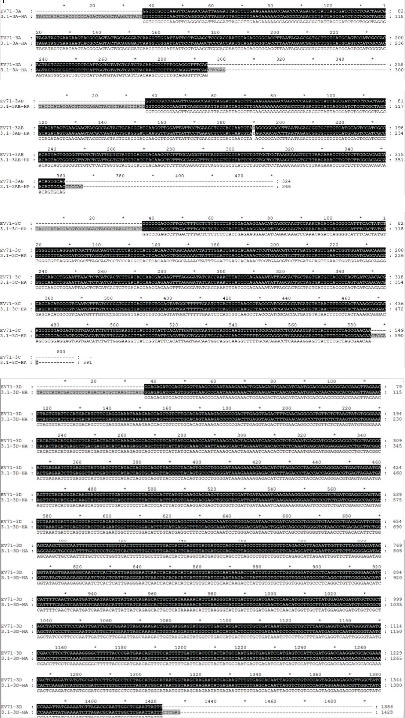

Figure S2. Recombinant plasmid sequencing results were compared with the sequence number JQ804832 of the EV71 type -XF strain found in Gene Bank. It assures that the virus genes

were successfully cloned into the pcDNA3.1(+)HA vector.

