Supplementary

A.R.T. allergy release technique® treatment components
(I) In each weekly ½ hour session, children are assessed for skin conductance levels (galvanic skin response (GSR)) at specified acupuncture points on the fingers (in Chinese acupuncture, points Nervous system NE-1b* and Allergy (upper toxicity), AL-1b*) in reaction to food and other allergens (e.g. dust and mold). The testing is done using the BioScan Device and the BioScan MSA Software (the BioScan MSA 141) developed by International Health Technologies (IHT). The BioScan Device has an FDA clearance as a Class II Device and is built by IHT at their HQ which is a registered FDA facility (http://www.International Health Technologies.com/fda-reg.htm).
The BioScan Device generates approximately 2.4 volts in its ohmmeter circuitry that is used to drive a current through the patient via two connection points. The first connection to the patient is a Stylus that is used to touch the acupuncture point on the hand of the patient. Then, the electrical circuit is completed through the patient and back to the ohmmeter circuitry by a brass cylinder (IHT HandMass), held in the patient’s other hand. Each GSR measurement results from a brief 2.4 volts (DC) pulse of less than 1 second to greater than 10 seconds for an extended reading. The main path of the current through the body is referred to as the meridian line connected to the patient's acupuncture points when touched by the Stylus. Several studies have suggested that acupuncture points have lower electrical resistance and impedance (or greater capacitance) than adjacent tissues [1].
Foods or other environmental stimuli (e.g. mold) are placed on a metal tray, also connected to the device, while acupuncture points are being assessed. The data from the ohmmeter is translated into a digital reading score on the Voll scale of 0-100 (for a discussion of the Voll scale, see Mayor (2007) below) [2]. Using the Voll Scale, readings from 45 to 55 are considered to be optimal or balanced.
Readings above and below the 45-55 range are thought to show an “imbalance”, with readings below 45 indicating that the cells along the acupuncture meridian have low energy (hypo-imbalance or “stressed”) as shown by increased resistance, and with readings above 55 indicating the cells along the acupuncture meridian have high energy (hyper-imbalance or “weakened”) shown by decreased resistance.
The body’s reactions to allergens are also assessed using the Bioscan MSA software, which has a library of electrical stimuli corresponding to foods, environmental and chemical stimuli (e.g. dust, mold, perfumes), and specific bacteria and viruses. Each stimulus consists of a frequency and a digital wave shape stored in a hexadecimal format. The software converts that into a signal when required. Each signal is designed (based on a proprietary technique) to simulate the same modulation of a skin conductance reading caused by exposing the patient to a specific substance such as peanuts or a chemical.
When a particular allergen or substance in the library is highlighted on the computer while skin conductance at the acupuncture points is being assessed, the MSA Software sends the specific digital signal of that substance to the stylus and through the body of the patient. The BioScan Device then measures the response to this stimulus and converts the response into a reading on the Voll scale.
(II) Electric current stimulation: Each session the ART practitioner tests skin conductance to food allergens and environmental substances, such as dust, mold or perfumes, as well as any bacteria or viruses that affect the immune system using the BioScan MSA software.
If any of these result in Voll scale readings above 45-55, the patient is then exposed to radio frequencies with pulses of approximately 556.8 ± 0.1 kHz for 1 to 3 minutes while the particular substance is highlighted in the computer library. The radio frequencies are generated by an antenna within the BioScan Device and patients are exposed to the radio frequencies either by being in direct proximity of the antenna or by wearing a “Focus” device necklace attached via a USB port that delivers the specific radio frequencies through the device. The amplitude and frequency of the radio waves are altered depending upon the particular stimulus highlighted on the computer software.
(III) Exposure to food allergens: Once a balanced reading on the galvanometer is achieved for the food allergen for at least two weeks, minute amounts of the food are touched to the face and lips for 4-6 weeks. Then minute amounts are ingested at home, increasing in amount over the next few weeks, always in the presence of the parent. The exposure protocol, including continued exposure to allergens post-treatment, is detailed in Table 1, Figures 1-2.
4-6 weeks prior to ingestion | Once a balanced reading on the galvanometer is achieved, small amounts of food are touched to the face and lips.
Week 1 | Minute amounts are ingested at home, always in the presence of the parent. Children begin by ingesting a psspa of the food every day.
Week 2 | Ingest ssspb every day.
Week 3 | Amount is doubled every three days.
Week 4 | Amount is doubled every two days.
Weeks 5 and 6 | Amount is doubled every day.
Week 7+ | Gradually built up to a standard serving amount of the allergen per day based on the age of the child.  For children age 4-11: Standard servings are approximately 5 peanuts, 4 oz of yogurt, 5 oz of milk  For children aged 12-18: Standard sizes are approximately 10 peanuts, 8 oz of milk
Completion | Once children have finished their food exposure protocol and are eating standard amounts of food, they are advised to ingest the food with the specified allergen daily for three months, including 2 servings per day of milk (1 straight milk product +1 baked good day), and 6-8 peanuts or (the equivalent in peanut butter or candy/cookies) per day.
Completion + 3 months | After 3 months, they are advised to ingest at least 1 serving of milk or 6-8 peanuts (or equivalent in peanut butter or candy/cookies), for three times per week.

Table 1: The exposure protocol.

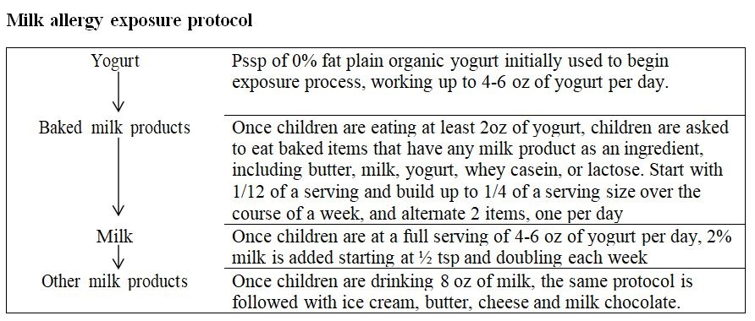

Figure 1: Milk allergy exposure protocol.

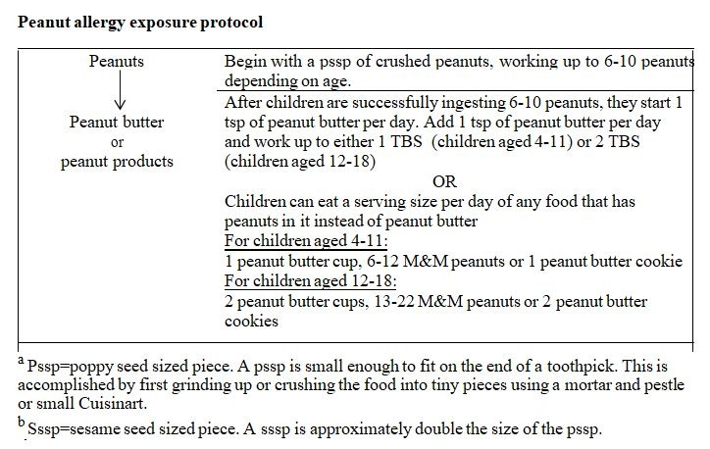

Figure 2: Peanut allergy exposure protocol.
For the exposures, parents are trained in managing allergic reactions, including epinephrine auto-injector administration and are given a written action plan to follow in the case of allergic reactions to foods. There are levels of response based on whether reactions are mild or severe that is prescribed in the immediate situation as follows:
For mild reactions, such as lip or tongue tingling, a few hives, mild sneezing, or scratchy throat, the following steps are taken:
(a) Spinal stimulation (tapping) accompanied by breathing, Emotional Freedom Technique (EFT) tapping [3] and positive coping statements (see below).
(b) Taking 1 to 2 tablets of Alka Seltzer Gold® @ in 6-8 oz. water. Alka Seltzer Gold® consists of the active ingredients of 1,000 mg of anhydrous citric acid; 344 mg of potassium bicarbonate and 1050 mg of heat-treated sodium bicarbonate. There is research that indicates that sodium bicarbonate prevents and remediates allergic responses [4,5] and ART has found ingestion of Alka Seltzer Gold® to be consistently helpful.
(c) Remaining at the same level of food exposure for an additional week before continuing to increase ingestion levels.
If the above steps 1 (a) and (b) do not stop the reactions within 2-3 minutes, the following steps are taken:
(a) Age appropriate dose of Benadryl. If the reaction subsides with the administration of Benadryl, participants are advised to cut back by ½ the amount of food allergen they are ingesting for a week and then continue to increase ingestion levels as described in the above protocol.
(b) If symptoms progress or if the patient has diffuse hives, respiratory symptoms (cough/wheeze), persistent gastrointestinal symptoms, or other signs of anaphylaxis, then the patient is advised to move to epinephrine auto-injector administration and call 911. If patients require epinephrine auto-injector administration, the dose may be cut back further or the protocol discontinued. Although systematic data have not been collected, including frequency of epinephrine auto-injector use, clinical impression indicates that about 30% of the children who have undergone the ART protocol have some allergic reactions to foods to which they are being treated. Additional clinical data indicate that 7% of 377 children who have started ART in the past 12 years have withdrawn from treatment.
(IV) Spinal stimulation and tapping: Both after electromagnetic stimulation as well as after ingestion of foods, the side of the examiner’s hand is used to tap the child’s spine in the sequence displayed in Figure 3. In addition, children are taught acupoint stimulation using a variation of Emotional Freedom Technique (EFT) which involves the child using the fingertips of both of their hands to tap acupuncture points in a particular sequence. When they expose themselves to food at home, they are asked to do this tapping as well as to simultaneously repeat positive coping statements to themselves as consistent with CBT.
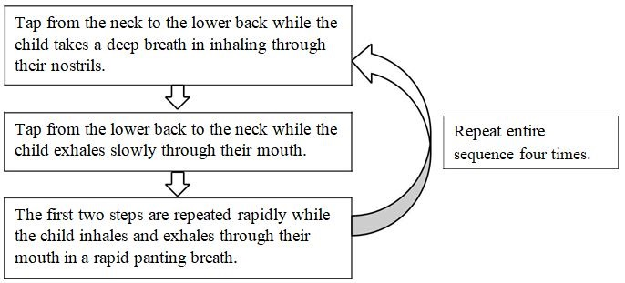

Figure 3: Tapping spine with side of hand.
(V). Cognitive-Behavioral Component, developed in collaboration with one of the authors, LB [6]: Children create a motivational board that has columns for (a) the foods they would like to eat (b) statements of how their lives will change when they no longer have allergies, e.g. “I will be able to eat in restaurants” or “I will be able to stay at friends’ homes” (c) prizes they will get for successfully accomplishing each step and reaching their overall goals.
Children are taught that anxiety is the body’s protective defense against substances it believes to be dangerous. They are asked to (1) thank the protective/anxious part of themselves (some children give this a name and externalize it, e.g. “my worry part”) and let the part know they appreciate what it is trying to do but also tell it that they don’t need the part to work so hard and (2) generate and repeat positive coping statements such as “I am safe”; “I am okay”; “This food is safe”; “This is not dangerous”; “I don’t have to protect myself”; “Other kids eat this food and they are perfectly safe”; “This food is delicious and I want to enjoy it”. They are also asked to identify times when they have felt strong and brave and when the anxious part makes an appearance, to remember those strong times and to repeat that they are brave and safe.

References
- Ahn AC, Colbert AP, Anderson BJ, Martinsen OG, Hammerschlag R, et al. (2008) Electrical properties of acupuncture points and meridians: A systematic review. Bioelectromagnetics 29: 245-256.
- Mayor DF (2007) Electroacupuncture: A practical manual and resource. Churchill Livingstone Elsevier Ltd, London.
- Feinstein D (2012) Acupoint stimulation in treating psychological disorders: Evidence of efficacy. Rev Gen Psychol 16: 364-380.
- Garcia AJ, Dominguez SJ, Rivera JM, de Rojas HD, Saltos EM, et al. (1986) Exercise-induced anaphylaxis: Inhibition with sodium bicarbonate. Allergy 41: 471.
- Katsunuma T, Iikura Y, Akasawa A, Iwasaki A, Hashimoto K, et al. (1992) Wheat-dependent exercise-induced anaphylaxis: inhibition by sodium bicarbonate. Ann Allergy 68: 184-188.
- Brody LR (2012) The bouncing worry ball and mighty mitt: A story, workbook and coloring book to help kids overcome anxiety about allergies. Lulu Press, N.C, USA.

